Turtlebot Software for Schools Outreach

Cate Fitzpatrick

Department of Computer Science

Aberystwyth University

Wales

September

2025

This thesis is submitted in partial fulfilment of the requirements for the degree of Master of Science

Degree: MSc Advanced Computer Science

Module: Dissertation (CHM9360)

Supervisor: Dr Neal Snooke

Abstract

A PC application was requested that could be used to create and run programs for a turtlebot made by Dr Neal Snooke. The application should also have a turtle simulation to control alongside the turtlebot. The intention is for the application to be used to provide an activity for outreach and open days.

The application was developed using the Python language and the CustomTkinter user interface library. It also uses Python as the language that users can write their own code with.

Alongside the initial application requirements, additional features were added to make the application serve further related purposes, such as configuring the turtlebot’s settings using a setup wizard.

Declaration of originality

I confirm that:

* This submission is my own work, except where clearly indicated.
* I understand that there are severe penalties for Unacceptable Academic Practice, which can lead to loss of marks or even the withholding of a degree.
* I have read the regulations on Unacceptable Academic Practice from the University’s Academic Quality and Records Office (AQRO) and the relevant sections of the current Student Handbook of the Department of Computer Science.
* In submitting this work, I understand and agree to abide by the University’s regulations governing these issues.

**Name:** Cate Fitzpatrick   
**Date:** 04/09/25

Consent to share this work

* By including my name below, I hereby agree to this thesis being made available to other students and academic staff of the Department of Computer Science, Aberystwyth University.

**Name:** Cate Fitzpatrick   
**Date:** 04/09/25

Acknowledgement

With thanks to Dr Neal Snooke for providing an interesting project that allowed me to play with a robot.

Table of Contents

Chapter 1. Introduction 1

Background 1

Project aims and objectives 2

How the project was tackled 2

Chapter 2. Literature review 3

Introduction 3

The early history of Logo and Turtles 3

Later developments in Turtles and other robots 4

Conclusion 5

Chapter 3. Requirements 6

Basic project requirements 6

Additional project requirements 6

Methodology 7

Chapter 4. Spike work 9

Picking software 9

Executing a user’s code 10

Threading 12

Syntax highlighting 12

HTML pages 13

Chapter 5. Design 14

Users 14

User Interface discussion 17

Classes 20

Other Files 24

Setup wizard 24

Chapter 6. Implementation 30

Introduction 30

Basic functionality (pre-turtlebot) 30

Responsive design 31

The challenge of stopping a running program 31

Adding the turtlebot to the project 32

Moving the pen 32

UI developments 33

The creation of the top menu 35

Open day tweaks 36

Scaling the turtle 37

Setup wizard 37

Curves 39

Chapter 7. Testing 40

How testing was approached 40

Conclusion 40

Chapter 8. Packaging 41

Packaging 41

Using the application 41

Chapter 9. Critical Evaluation 42

Project strengths 42

Project Weaknesses 42

Future Work 43

Chapter 10. Conclusion 44

References 45

Appendix A 46

Appendix B- Ethical Clearance 47

Appendix C- Project Requirements 52

Basic Requirements (BR) 52

Additional Requirements (AR) 52

Appendix D- Turtlebot commands (created by Dr Neal Snooke) 53

Appendix E- Manual testing table 56

Appendix F- User Manual 64

Troubleshooting 64

Developing the application 65

Adding new commands 65

Adding new insert shapes 65

Changing the information/about pages 65

List of Figures

Figure 1-SCAD design of the turtlebot chassis (Dr Neal Snooke) 1

Figure 2- SCAD design of the turtlebot (Dr Neal Snooke) 1

Figure 3- The project's GitHub Board 9

Figure 4- Screenshot of turtle made with Java with its code 10

Figure 5- Screenshot of turtle made with Python with its code 11

Figure 6- Screenshot of input window for testing execution libraries 12

Figure 7- Screenshot of code and the window it produces for testing Python's threading 13

Figure 8- Turtlebot application's use case diagram 17

Figure 9- UI initial mock-up 18

Figure 10-UI after combining spike work 19

Figure 11-Final UI 20

Figure 12-Spyder's layout 20

Figure 13-Application’s class diagram 21

Figure 14- Top_Menu's classes 24

Figure 15- Setup wizard flow chart 26

Figure 16- Setup wizard flow chart: Setting the backlash 27

Figure 17- Setup wizard flow chart: Wheel diameters 28

Figure 18- Setup wizard flow chart: Axle length 29

Figure 19- Setup wizard axle drawing 30

Figure 20- Extreme example of "spamming" the run button 31

Figure 21-Horizontal original application logo 34

Figure 22- Final logo design 35

Figure 23-Original turtlebot bird’s eye view 35

Figure 24-Picture with PowerPoint blocks overlaid 35

Figure 25- Abstract turtlebot GIMP image 36

Figure 26- Axle and pen paths for a circle 39

1. Introduction

## Background

Before the project began, a turtlebot had been created. The purpose of this turtlebot is to have it draw shapes using its pen by moving the turtlebot around on a piece of paper. The turtlebot was designed using OpenSCAD and then 3D printing the chassis and wheels. The designs of which can be seen in Figure 1 and Figure 2.

The turtlebot has four main features. Two wheels that are controlled by stepper motors to move the turtlebot, a screen display and a component where a pen can be put in, which can then be moved vertically by a servo. The turtlebot’s firmware uses an Arduino and also has a Bluetooth component in order to receive and acknowledge commands from a USB dongle that is plugged into the PC.

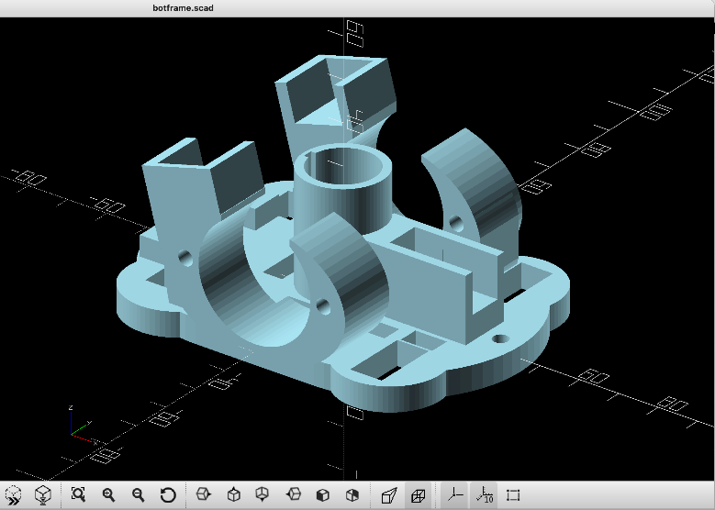

Figure -SCAD design of the turtlebot chassis (Dr Neal Snooke)

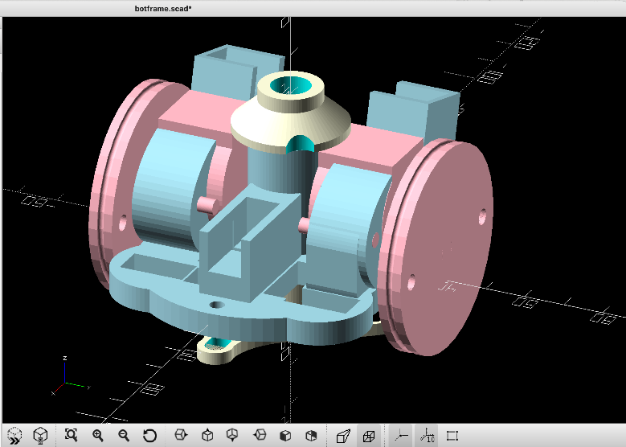

Figure - SCAD design of the turtlebot (Dr Neal Snooke)

In addition to the turtlebot, some simple software had been made using Java to connect to the turtlebot and then send it commands. These commands included ones to adjust the pen height and move the wheels. The movement commands have options to move in either millimetres or motor steps (with 4096 steps per rotation). Initially, the movement command options were for moving forward, left, or right.

The intention for the turtlebot (and the ones produced later) was for them to be used for outreach and open day activities so that young people and prospective students could have a go at controlling them and drawing shapes.

To this end, an application with a simple graphical user interface (GUI) was desired so that users could type in their code and send it to the turtlebot. The application was also requested to have a virtual turtle. This would prove particularly useful for quick testing or if there were only a limited number of turtles available to share around. The creation of this application was the objective of the project.

An application was required so that code development for the turtlebot could be done in a user-friendly manner and have the ability to provide feedback for code, which would be an improvement to the original Java software. This application would need to be easily distributable onto the devices to be used for open days and outreach. A standalone application is beneficial for this, as no additional software installations would be required to run it, beyond the application itself.

## Project aims and objectives

The project aims to create an application that beginner programmers can use to develop their coding skills by controlling a turtlebot, whether physically or virtually.

To do this, the application needed to include a place for the users to input their code, somewhere for them to receive feedback for it (such as for errors) and a virtual turtle. For connecting to the turtlebot, the application needed a way to open and connect to the correct port and ideally show the user if they had managed to successfully connect, so they could then send the turtlebot their code.

Additional requirements for features were added as the project progressed to help the user have a better experience, including the ability to save and load the developed code, as well as an information page so users could find out more about the project and the commands they could use for the turtlebot.

## How the project was tackled

The project was created as a CustomTkinter application in the language Python. It was developed by breaking the project into feature chunks and tackling it in an agile manner. This was partially done to fit better with the project’s changing requirements as multiple were added during the project’s lifetime.

First, the ability for the user to code and have a virtual turtle respond was tackled. From then, the turtlebot was introduced, so connecting the turtlebot and sending it commands became the focus. Once these two components were addressed, the project shifted its focus to additional features to enhance the user experience, which is where the additional features were added in.

This paper looks at how the project was developed and how it compares to similar ones. First, the history of turtles is explored with its Literature review to then move to the creation of the desired product. The Requirements section breaks down the requirements of the application to achieve its aims. The options to meet the requirements were then explored by doing Spike work. Once these options have been explored, the Design chapter describes the design of the application with the necessary classes, files and steps based on user requirements. How this design was carried out is described within the Implementation chapter. The approach and success of testing are discussed within the Testing chapter, and the testing itself can be found in Appendix E. How the application was packaged for distribution is included in the Packaging chapter. The paper concludes with a Critical Evaluation to compare the created application to the initial aims and objectives, along with any future work that could be done.

1. Literature review

## Introduction

The use of robots to help people develop their coding skills has been a long-standing practice spanning over 50 years. A large quantity of these robots has had options to draw lines and shapes. Although the aims and base functions of these systems have not changed drastically, the hardware and software have developed over time to provide a better user experience. Two examples of these developments are hardware parts becoming smaller and cheaper, and the addition of graphical tools. The first Turtles were developed as part of the development of Logo [1]. Many of the more modern versions, software and hardware, have stemmed from this, such as Python’s Turtle Graphics [2][3].

This literature review will explore the history of Logo and turtles, as well as other systems with the same aim.

## The early history of Logo and Turtles

### Logo

Logo was first invented in 1966 by Seymour Papert, Wally Feurzeig and Cynthia Solomon. In 1966, Papert visited multiple classes using programming languages and decided that a programming language designed specifically for children was required [4]. This language was then made and used in labs within the same year [2]. By 1967, the language was being tried out in schools.

Logo is a dialect of Lisp with some changes. One of the most significant changes was the introduction of commands [2]. Before this, there were only procedures that could not return values. By introducing the option to return values, the options for programs greatly increased. Other smaller changes were made to make the language more child friendly. Lisp uses many parentheses, putting them around everything. Logo removed these.

Another choice taken to make Logo simpler is that it does not have an IDE. The idea behind this was that the focus was to learn the language rather than trying to learn an IDE as well [2].

The first Logo programs were used for playing with words and sentences, aiming to help children play around with them and learn grammar in the process [2]. One example of this was turning inputted words into pig Latin. These programs were originally run on time-shared computers (Digital Equipment Corporation PDP-1) [2].

The new language was seen to be successful, especially when the Logo environment ideology was kept to, which involved a culture of learning by doing [1]. The Logo group was officially formed at the MIT AI Lab in 1969 [4].

### The introduction of Turtles

The idea of having physical objects to further develop the project was worked on between 1969-70 [2]. Two of the objects produced were Turtles that could draw lines based on the commands they were given. The name turtle was inspired by the two automations that William Grey Walter built, which he called tortoises (Elise and Elmer, more specifically) [2]. The original turtles did not have a graphical counterpart, which would come slightly later. The early turtles were connected to the computer via wiring to receive commands and send feedback [5].

The turtles had six commands: FORWARD, BACKWARD, RIGHT, LEFT, PENUP and PENDOWN. These could be combined within procedures to make a sequence of actions in hopes of creating shapes [1]. The layout of such a procedure to draw a triangle would be:

TO TRIANGLE

1. FORWARD 50
2. RIGHT 120
3. FORWARD 50
4. RIGHT 120
5. FORWARD 50
6. RIGHT 120

END

It was found that mistakes were more likely to lead to objective thinking, as students tended to blame the turtle rather than themselves [1]. This meant that problems were dealt with constructively, focusing on why an issue occurred rather than the error itself.

### The introduction of Turtle geometry

Turtle geometry was introduced in 1970. This allowed a user to view a simulated turtle and control it in the same manner as the Turtlebots, as they worked off the same six commands. Turtle Geometry worked with local geometry based on the ideas of current position and heading [2]. It used standalone graphics terminals [2].

One example of its use was by Jon Pledge, a 12-year-old at the time, who used it to create a universal maze-solving algorithm during an activity (now known as Pledge’s algorithm) [2].

After a conference in 1972, a company called General Turtle was formed to make and sell turtles [2]. Roughly three years later, Marvin Minsky designed a standalone graphics system for the company to sell [2].

### Logo since 1975

After the boom in personal computers, the development of Logo versions sped up [2]. As of 2016, Logo has over 300 versions according to Pavel Boytchev’s Logo Tree Project [6]. Some of these are similar to the original uses, while others differ. Various programming languages implement a version of Logo by having their own version of Turtle graphics. The language was also used to create block-based learning environments such as Scratch [6][7].

## Later developments in Turtles and other robots

Similar to how there have been many versions of Logo, there have also been many different robots that are used similarly to turtles, most of which have developed from the original Logo ones. Not all of them have the ability to draw, though many have it as an option, using modular sets.

The original turtles relied on a cord for communications. This was because radio links were considered to be too expensive, given that the turtles were being developed for use in schools [5]. Since then, non-wired transmission mediums have become cheaper (and smaller), so they are now the norm.

### BBC Buggy

The BBC Buggy launched in 1983 [8]. This came in a set that users needed to assemble themselves with a range of programs. This set was modular, so kits could be switched out depending on their intended purpose. One such kit was the pen kit that could be used with Logo to draw.

### The Valiant Turtle

Also released in 1983, the Valiant Turtle is controlled using Logo to draw. It also had an on-screen version [9]. The turtle was controlled with infrared.

### LEGO Mindstorms

In 1987, LEGO started a collaboration with Logo, whereupon the Logo group would create turtles for them [2]. The first was the LEGO TC Logo. This required the robot to have a wired connection between itself and the PC to get the PC’s commands to its main port. Other ports could be connected to sensors, lights, and motors [10].

After this, work started to put a processor into a large “brick” so that the bot could store and process its own commands. This led to the LEGO Mindstorms RCX in 1998. This concept was carried forward. Mindstorms are still sold today, though they have gone through a few evolutions and now use block-based programming [11].

### TurtleBot

The TurtleBot is more for adult users than the original turtles. They are based on Logo [12]. People can buy kits to make the robots, and this can lead to diverse applications, including home use and research [13].

## Conclusion

Many of the turtlebots and alternatives have had similar characteristics to the turtlebot for this project. The basic functions are naturally the same, as pen controls and movement requirements have not changed since 1969. The transmission of commands is similar to most other bots mentioned, with the exception of having a different medium, using Bluetooth rather than wired or infrared options. Like the original turtles, the turtlebots produced for the project are also made with the mindset of keeping production costs as cheap as possible.

The turtle graphics library that is used for the project is based upon the original one, using the same concepts of position and heading, even if the technology has advanced to where it no longer requires a separate graphics terminal.

The aim of turtles has not changed between the originals and this project. They both have the objective of getting beginner programmers to adopt coding by having a go.

The main difference between the application that will be produced, and previous systems is that it both uses a turtlebot and also gets users to code in a language that is commonly used for development outside of learning environments.

1. Requirements

## Basic project requirements

The project started with some simple basic requirements:

*Basic Requirement (BR)1: A user should have an application where they can write code.*

This requires having the application with a writeable textbox. It also implies picking the code language, either by creating one or picking an existing one.

*BR2: A user should be able to view a turtle simulation to see the output of their code.*

This requires picking a turtle library (or creating one, but reinventing the wheel is unnecessary). This simulation needs to be placed on the application screen and requires a way to receive the commands from the user-written code when the user wants it to.

*BR3: A user should be able to connect to and send commands to the turtlebot.*

The application will require the ability to connect to the turtlebot’s port and send it messages. It will need to be able to receive acknowledgements as well. This means that the code written by the user needs to either match the turtlebot commands or be translated into them before sending.

*BR4: A user can configure the pen height.*

This is so the pen can be configured to be just on the page to reduce damage to the pen. The user will require a way to adjust the down value to test out different values.

*BR5: A user should be able to receive error feedback on their code.*

The application will require a place to display error messages. This will show the user why their code does not work, so that it may be improved upon rather than leading to frustration from not knowing why.

## Additional project requirements

As the project progressed, more requirements were added beyond the basic functionality, as it became apparent that there would be time to do them.

Additional requirements:

*Additional Requirement (AR)1: A user should be able to stop the code when running.*

This is in case of the code being incorrect from what the user expected to happen, or in the case of needing to stop the turtlebot (e.g. it has run off the paper). This will require a stop button that can stop both the simulation and the turtlebot.

*AR2: The user’s code input box should have syntax highlighting.*

This is so the user can get debugging information before trying to run the code. For instance, if what is intended to be a string is not highlighted as such, it visually indicates that the code has an error.

*AR3: A user should be able to access information pages.*

This is so that the user can access additional information about the turtlebot. They can also view the possible commands that they can type. For this purpose, the pages should be viewable from a separate window so that the user can go back and forth easily between viewing them and the main application to type the commands.

*AR4: A user should be able to change the font size of the code text and output text.*

The application should allow the user to change the font size. This allows the application to be used and the code to be read on different screens and increases the application’s accessibility.

*AR5: A user should be able to save their current code and load their code from a file.*

The application should allow the user to save their current code that they have been developing, as well as load it back in. This means that the user will need buttons to access these functions. The user should also be able to name their file when saving so they can recognise it when trying to load it later.

*AR6: A user should be able to set up the configurations of the turtlebot so that the drawings will be precise.*

The application requires a setup wizard-type process so the turtlebot can be configured with accurate values for its axle length, wheel diameter and motor backlashes. This is not to be done by the general user but will be required during the initial setup of the turtlebot and potentially later if drawing imprecision is found.

This will require a separate window guiding a user through drawing steps and what to measure. This separate window will need to be accessible through the main application.

*AR7: A user should be able to insert premade characters and shapes.*

This will allow users to quickly generate words and shapes. One benefit of this is that beginner users can view how to make a shape and then play around with the code it gives them to match their purposes. This introduces a stepping stone into learning the system for those who are struggling to get started with the program.

To do this, the application will require a list of available shapes that the user can select from. The code to make the selected shape will then need to be retrieved or generated to then be inserted where the user types their code.

All requirements can be found in Appendix C.

## Methodology

To meet these changing requirements, a fairly agile approach was taken using a GitHub board to track progress. The requirements were broken down into smaller chunks.

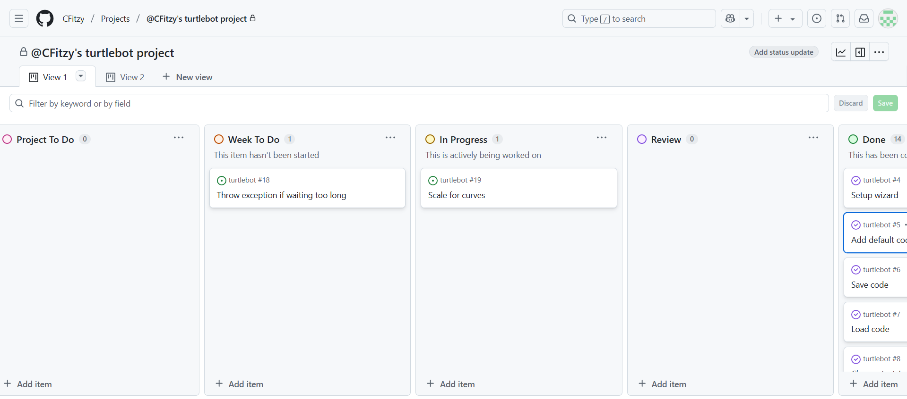

Figure - The project's GitHub Board

As seen in Figure 3, the board was loosely based upon Scrum, with the idea of picking items to do each week from the Project to-do list/backlog. Some requirements required more than one week, and some others went back onto the to-do list once it became apparent that they needed further work.

As the project progressed, the board was used less as the backlog reduced, so tracking project progress became simpler, especially given its nature as an independent project. During later stages of the project, a simpler to-do list was kept, and items were removed as they were completed, rather than using the whole board. Newer requirements were added to this list as required.

1. Spike work

Before the application program could be developed, some design decisions needed to be made. These decisions were made by testing out the various options via spike work, creating small example programs for various features that would eventually come together within the resulting application.

## Picking software

The two obvious language choices for creating the application were either Java or Python.

### Java

Java had the benefit of already being proven to be able to communicate and send commands to the turtlebot.

Java also has a turtle library, which can be used to create a virtual turtle and program it with its commands (as seen in Figure 4), and with an additional library such as JavaFX, an application could be produced using this.

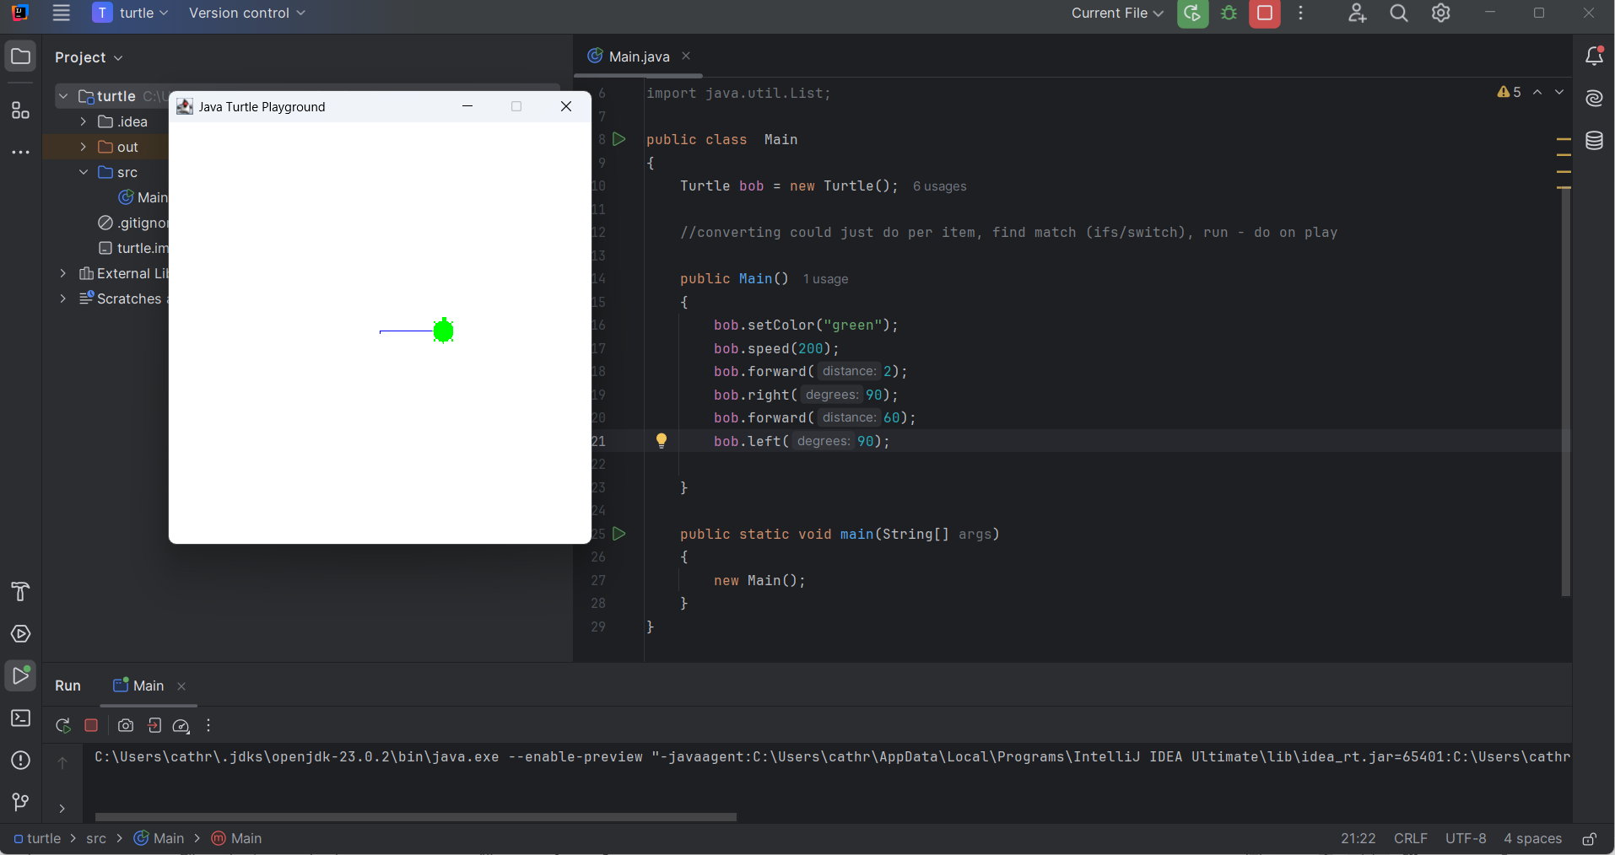

Figure - Screenshot of turtle made with Java with its code

One major downside of using Turtle with Java is that there is limited documentation for it, with no central place for information. This makes it harder to develop a more complicated system with it.

### Python

Python also has a turtle library, which can be used in a similar way to the Java one (as seen in Figure 5). It also has formal Turtle graphics documentation [3] which can be easily accessed. Spike work was additionally done to check that the turtle could be embedded into a window, which could have additional features added to it, such as a button. CustomTkinter was used for this, given previous familiarity with it.

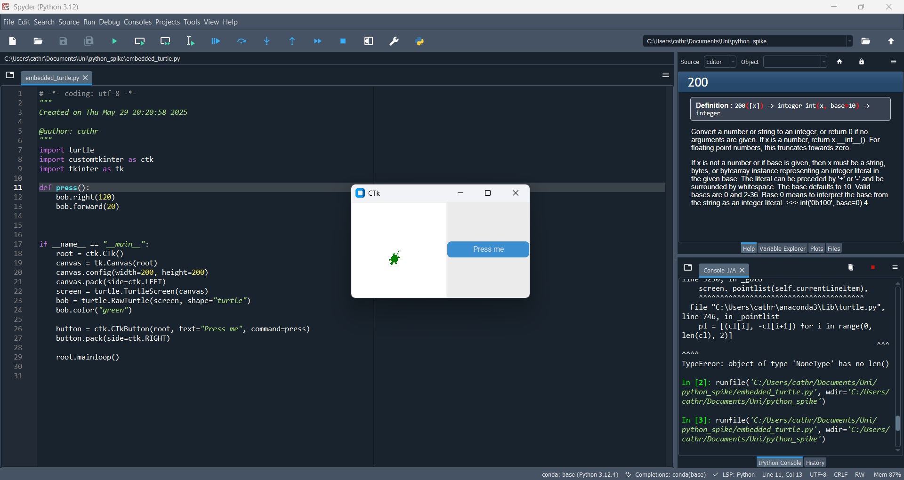

Figure - Screenshot of turtle made with Python with its code

Creating the application in Python can also allow users to write their code in Python. This achieves the application's aim of getting users coding with a proper programming language, whilst making development easier as no translation would be needed between languages. Python has the additional benefit of easily being able to compile and run an executable program within the current program dynamically. More information about this is given in the next section.

Python is quite commonly taught in schools, so a fair few potential users may already have some familiarity with it. It is popular since it resembles spoken English in many ways, so it can be easier to pick up. Given this, it may prove to be a beneficial choice for activities for outreach and open days.

The downside of Python is that connecting to the turtlebot has not previously been worked out, but given Python’s popularity and large amount of documentation, there is likely to be libraries and advice out there to achieve this purpose.

### Conclusion

Python was chosen for the reasons listed above. The CustomTkinter library was chosen to build the GUI, as a turtle could be easily embedded. CustomTkinter builds upon the Tkinter library, which is one of Python’s basic GUI building libraries. CustomTkinter allows Tkinter to be used alongside newer elements such as themes and more modernised GUI features.

## Executing a user’s code

For a user to be able to create code and then run it within the application, it is crucial to have a way for the code to be retrieved and run dynamically. Python has multiple libraries and ways to do this, with their own benefits and drawbacks.

These were explored for their suitability by having a simple Python file that would print “hello world” if executed correctly. Another file with the chosen method to read in the file and execute it was then created. These were tried both with the hello world file being correct and when it had errors.

Once the options had been explored this way, they were tried with a CustomTkinter window containing a textbox where “print(“Hello world”)” was written and a button that called a command to run the code that was written. This can be seen in Figure 6. The command was changed to use each library option.

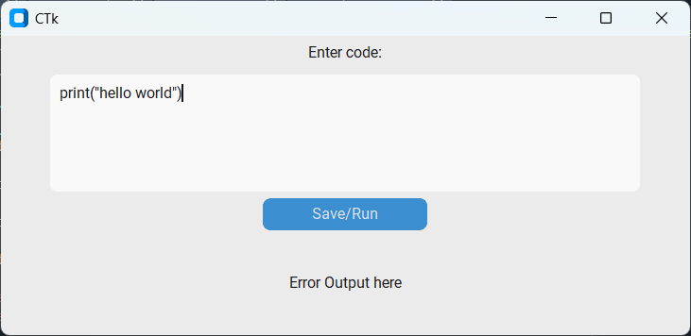

Figure - Screenshot of input window for testing execution libraries

### The subprocess module

The subprocess library has multiple functions that were tested out. The options of call, run, and Popen were all tested out. These all did not output the expected result of “hello world”. By using the check_output function and then printing out its results, it can be found to return "b'hello world\r\n'”. After investigation, the subprocess library seems to be more for running command-line processes rather than Python files, making it not suitable for this project.

### The os module

The os module offers the system function that can be used to read and execute files. It proved to be effective for the first test, printing “Hello world” to the console. Once CustomTkinter was introduced, it stopped functioning.

### The exec function

The exec function is one of Python’s built-in functions and executes the string of code it is given. To use this, the Python file must be opened and read, then the contents passed to the exec function. All these functions are within Python’s standard library. This method worked successfully for both tests. For the first test, code errors in the hello world file caused the system to stop. This was not a problem once CustomTkinter was introduced, as the application would keep running, although throwing errors when the code was wrong.

This method has the original benefit that it does not require the input to come from a file, as the exec function is looking for a string. This means that the code can be retrieved straight from the textbox and passed to it, skipping the middle steps.

The main issue with the exec function is that it will try to run any code it is given. This means it has security issues, though, since the use of the application is likely to be monitored, it should be a minimal issue for this particular application.

The exec function shall be used as it works the best for the intended purpose.

## Threading

Research was done into threading with Python, as the application would require multiple processes to be handled at once. Python is single-threaded by default, and many libraries rely on being on the main thread, such as CustomTkinter. Self-made processes can be run on separate threads. This was attempted, utilising the turtle module to get two turtles to run in parallel to test using the threading library (which can be seen in Figure 7). This was successful, so it will be usable for more complicated parts of the final system.

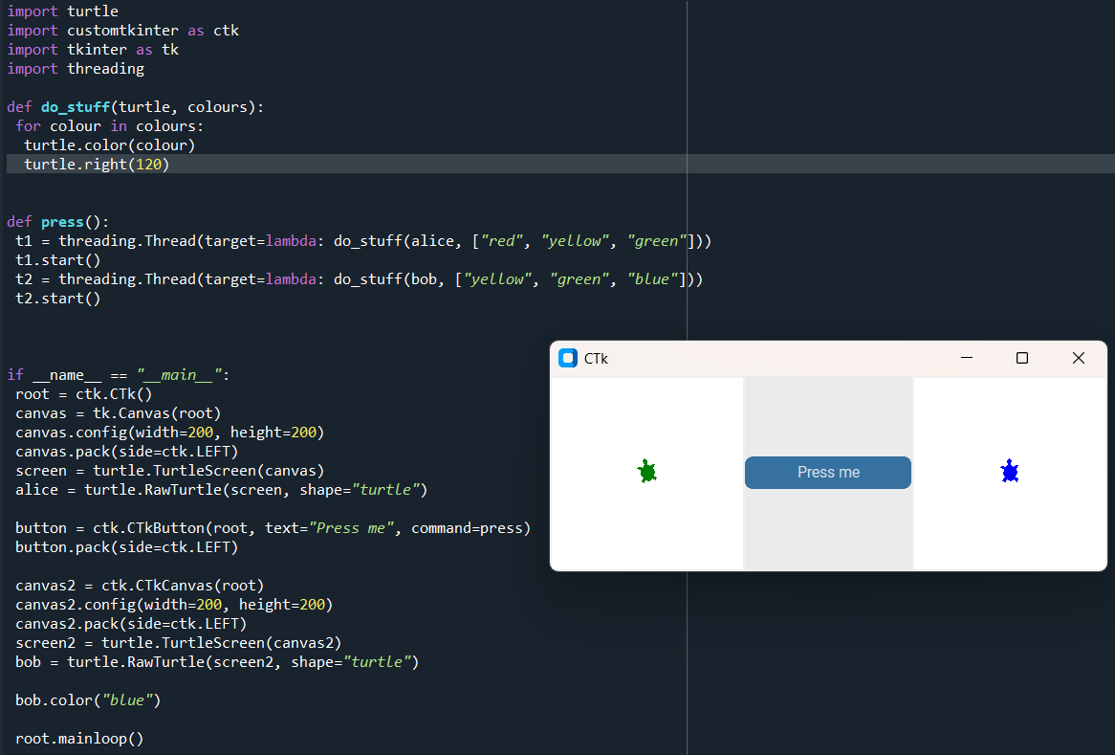

Figure - Screenshot of code and the window it produces for testing Python's threading

## Syntax highlighting

For a better experience, it was decided that syntax highlighting would be useful for the text box where users enter their code. This could be done for known keywords, such as for if statements or strings, but would be better done with a library, as all the main keywords and syntax would already be known. There are a few libraries that serve this purpose. Two of the most common ones for use with Tkinter are idlelib and Pygments. Both libraries were fit for purpose when tried out, producing the same result from the user's point of view.

Given that the application is intended to be kept simple and easily maintainable for developers, Pygments proved bulkier and required more lines of code to achieve the same result. Idlelib is more streamlined from a developer's point of view and allows for easy choosing of colours for each kind of syntax highlighting that is wanted. Therefore, idlelib was chosen.

## HTML pages

The user will require some guidance about what code they can write and may wish to learn more about the software and hardware. To this end, an information page would prove beneficial. To do this, it was decided to write the information in a HTML file for the application to then open and display on a separate window. This way, the pages could be updated without prior Python knowledge and without having to open the main code. A library that could provide this function was therefore required.

There are two main libraries that can open HTML pages inside Tkinter windows, both of which have their own benefits and drawbacks.

### tkhtmlview

The tkhtmlview library is specifically designed to work with Tkinter. HTML pages can be opened using it by putting files into its objects, such as its HTMLScrolledText, which can then be packed and displayed in a window. The main drawback of this library is that it doesn’t support the navigation tag. When used, it tries to open an unreachable webpage.

### Webview

The Webview library works by creating a new window using the HTML file. This works when it stands alone, and the navigation tag can be used. Problems arise when attempting to move between the About pages and the application’s main window. Doing that causes the application to crash. Since the pages are designed to be referred to for command options whilst typing them, this is less than ideal. The Webview library only functions on the main thread, so putting it onto an alternative thread was not an option.

### Conclusion

The tkhtmlview library was chosen to be used since it mostly worked, and its drawback was minor in comparison.

1. Design

## Users

The application will need to be used by different types of users. These can be broken down into different groups, though there is a large overlap in required features.

User types:

* Young and/or prospective students via open days or outreach activities who are new to coding.
* Other students who have had more coding experience
* People demonstrating the turtlebot’s capabilities to draw more complex designs or leading activities using the turtlebot.
* The person who is doing the initial configuring of the turtlebot (using the setup tool)

The varying range of coding experience means that the application needs to be designed in a way that is beginner-friendly, with additional guidance available, whilst allowing those who are more familiar with the concepts to get on with coding. This means that the application should allow the users to access more information rather than have it forced upon them, i.e. having them have to complete a step-by-step tutorial before starting. Help/information pages are useful for beginners, along with an example which can be provided as a default.

Given that some students will have had experience, it is better to have the application laid out in a way that is not too dissimilar to similar applications so that they can navigate easily without having to relearn aspects. It should also include some features that they would expect, such as syntax highlighting.

For those demonstrating the software, they may require having the screen display on different sizes of screen, so the ability to alter the text size so it could be read across a room would be beneficial. It may also prove useful to be able to insert or load pre-made drawings/code to be able to demonstrate a design developed on a prior occasion.

The person configuring the turtlebot will need a way to step through the stages to do so. More information on this is available later in the chapter.

### Use cases

Based upon the requirements discussed within the requirements section and the types of users, certain use cases became apparent (see Figure 8).

UC1 Writing a program: When a user wants to write a program, they have various options they can choose to do.

UC1.1 Enter code: The user can click and type their code into a textbox.

UC1.2 Run code: The user can click a run button to run their code on the simulation (and the turtlebot). The user can also choose to stop the program running whilst it is running in case of an issue or undesired behaviour.

UC1.3 Clear program: The user can choose to clear the code textbox and restart with an empty one by clicking the clear program button.

UC1.4 Reset turtle: The user can choose to reset the virtual turtle to its original starting position.

UC2 Connecting the turtlebot: When a user wants to connect a turtlebot, they can pick an available port, and the application will display if it has successfully connected with the turtlebot. The application will then send commands to the turtlebot when the user prompts to run the code.

UC3 Setup wizard: When a user wishes to configure the turtlebot, they can open a setup wizard that takes them through steps to configure the wheels’ backlash, diameter, and the turtlebot’s axle length.

UC4 Adjust the pen height: The user can change the height of the turtlebot’s pen until they are happy by selecting different ones.

UC5 Change the font size: The user can open the menu and select a new font size to change the text size of the code text and output text.

UC6 Save code: The user can select to save their current code from the menu and name the file.

UC7 Load code: The user can select to load a file. They can then pick a file to load into the code textbox.

UC8 Insert shape: The user can select a shape or character to load into the code textbox via the menu.

UC9 Reading the About page: The user can click on the About button on the top menu to load an additional window with more information about the project, for those curious, and with extra directions about coding and what commands are available to them.

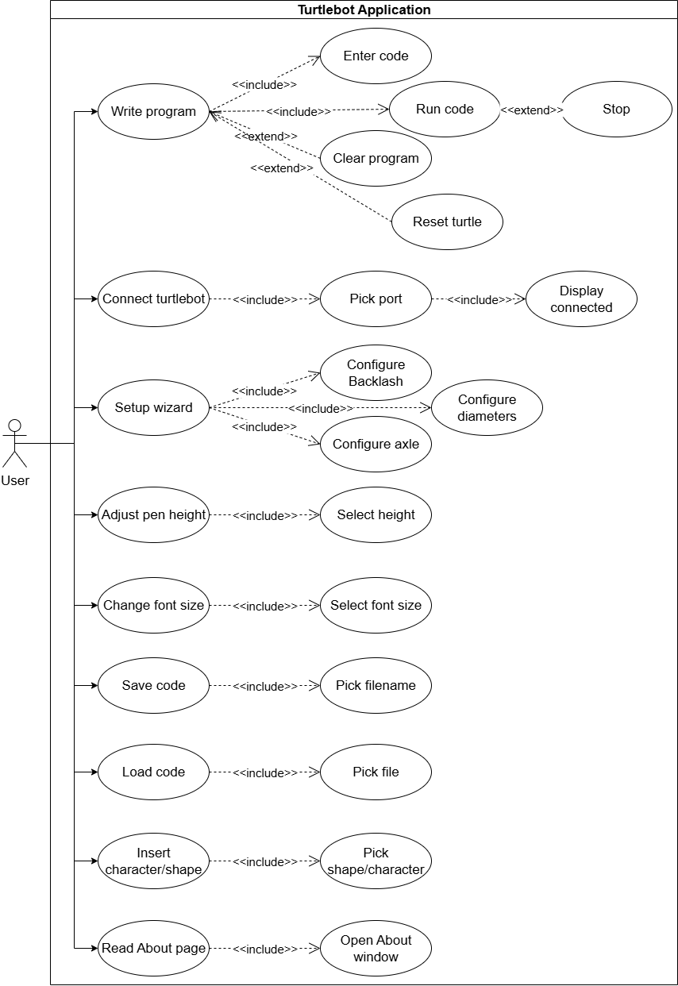

Figure - Turtlebot application's use case diagram

## User Interface discussion

The user interface needed to be kept as simple as possible whilst still being visually appealing. This meant intuitive buttons and colour were required, whilst also trying not to overcrowd the application. The less commonly used features were planned to be kept near the top of the screen, where they would be out of the way of main use.

To get an idea of the initial design, Microsoft PowerPoint was used to create some mock-ups based on the initial requirements. One of these mock-ups can be seen in Figure 9.

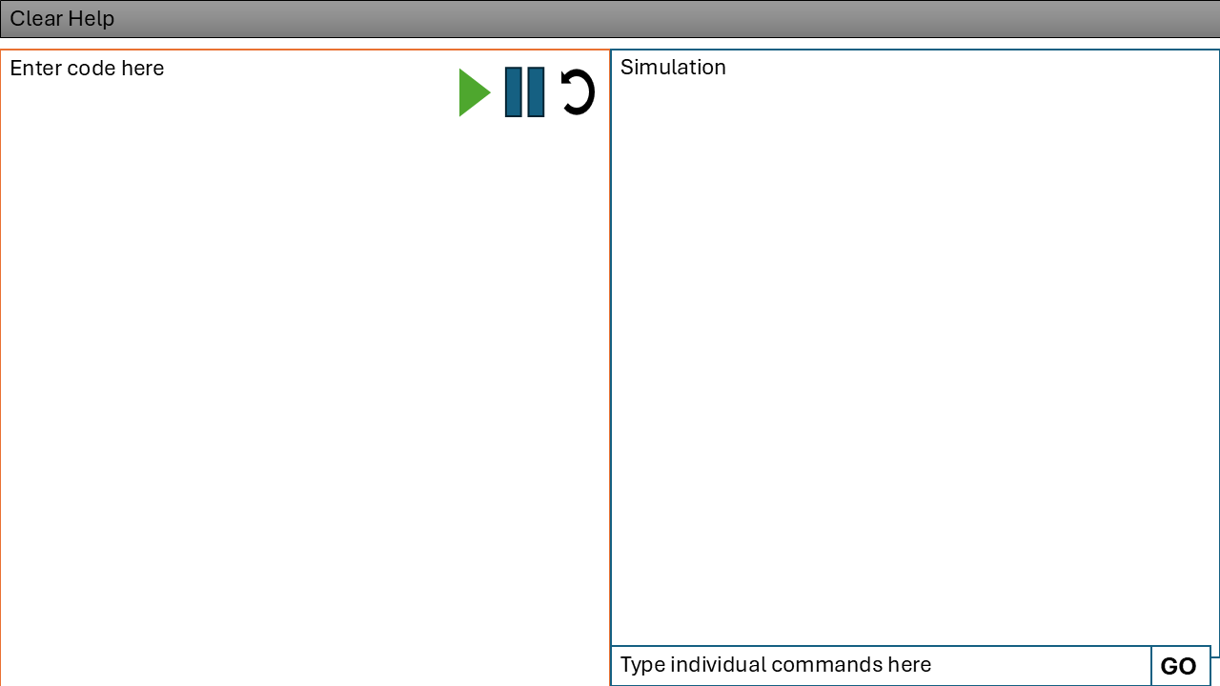

Figure - UI initial mock-up

From the beginning, it was clear that the user would require a large place to type their code, a place to view it in action via the simulation, and various buttons to run the code, pause/stop it and reset it. These buttons would later be moved to the right-hand side.

During the spike work process, an output box proved useful for displaying messages when errors occurred with the code. This was deemed an important requirement for the end UI, so it was incorporated into the design, as can be seen in one of the early iterations of the design. Figure 10 shows a design with this new box incorporated.

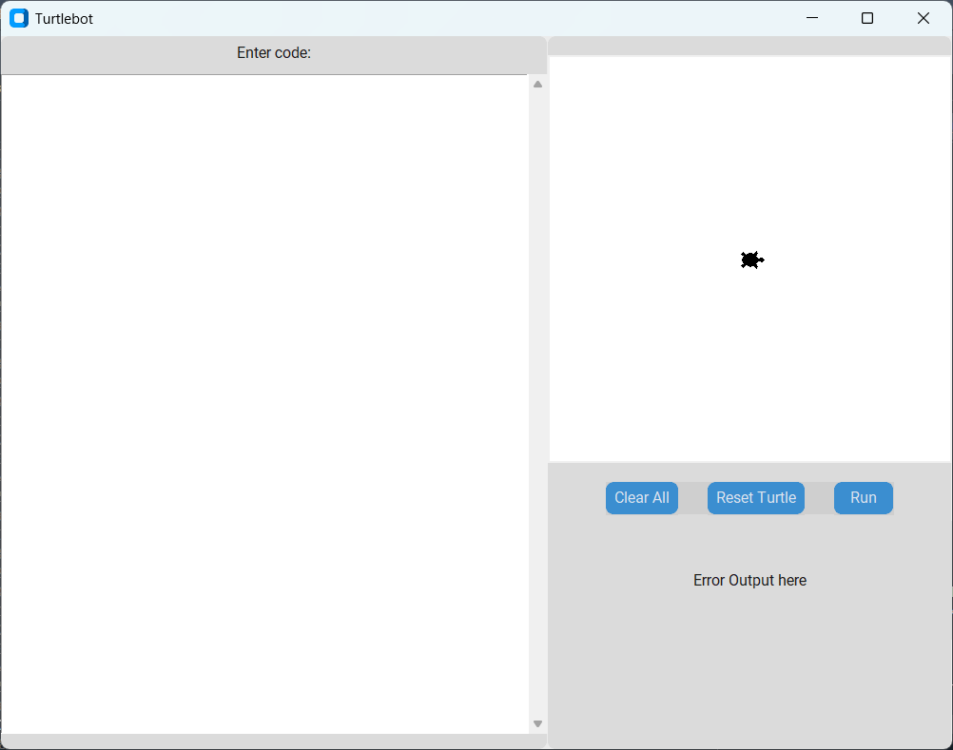

Figure -UI after combining spike work

Over time, other user interface components were added to the design to access the newly added features. This mainly consisted of what can be found on the top menu now.

The colour green was picked as the application's main colour. This was picked as the colour was deemed appropriate for turtles.

The final design can be seen in Figure 11. This includes the applications icon, which is based on Python’s Turtle library’s turtle.

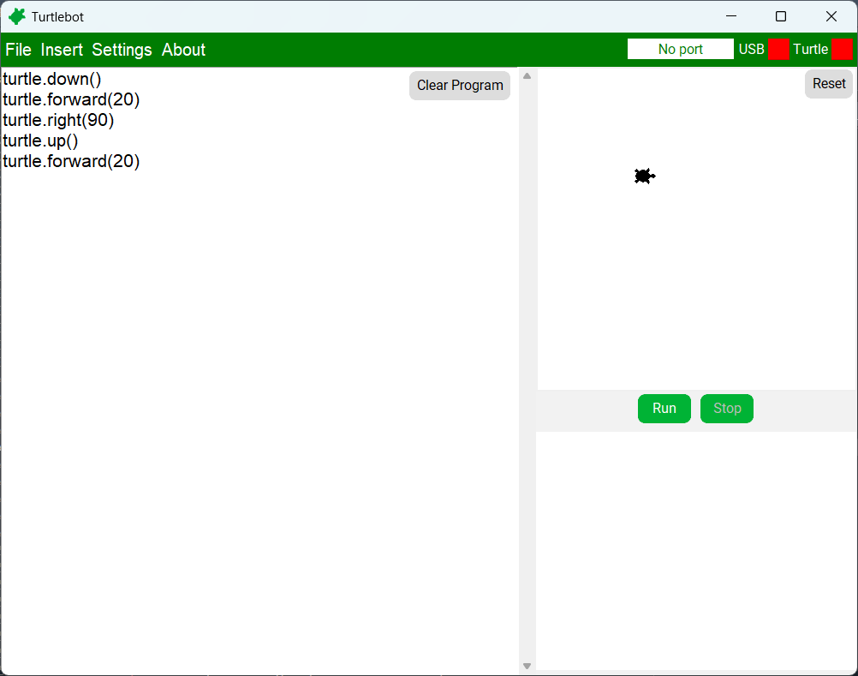

Figure -Final UI

The final user interface layout shares a lot of similarities with Spyder’s layout, which was used to create the code. This can be seen in Figure 12. There is a chance of unconscious bias towards this design; however, it does seem to work for Spyder. There are some design differences, for instance, the run button is in a different place, and Spyder does not have a virtual turtle.

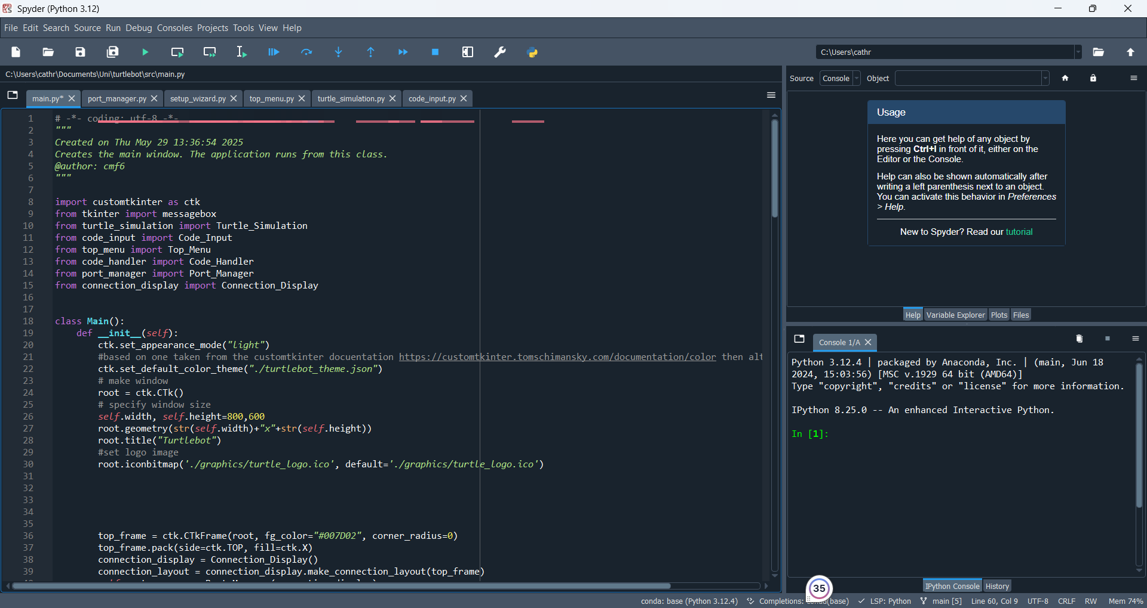

Figure -Spyder's layout

## Classes

### A screenshot of a computer program AI-generated content may be incorrect.Classes for programming and operating the turtle

Figure -Application’s class diagram

As seen in Figure 13, the application consists of twelve classes. Most of these classes contribute towards the UI aspects of the application as well as other functions. The classes handle a feature, rather than separating the visual and background portions of the application.

#### Main

The Main class handles the creation of the basic application by utilising other classes. It acts as the class that links the others. The Main class is where the application is controlled from, and the UI components are combined by passing the window frame to various components.

Most of the instances of classes are created here to then be passed onto the classes that need them. This is because the classes need to be singletons, and the classes that use them need to access the same instance. The order of other classes being created is important so that the layout is created correctly, as well as each class having access to the objects they need to function.

The main class creates the instances of the Connection_Display, Port_Manager, Code_Handler, Code_Input, Top_Menu, and Turtle_Simulation classes in the order listed. It also creates the run and stop buttons and has functions to handle passing instructions to various classes. Some of its other functions handle window-related actions such as resizing and closing.

The main class also uses a file to determine the application’s theme and an image file for a logo.

#### Connection_Display

The connection display creates a simple design of two labels with coloured boxes to show the state of the USB and turtlebot connections. These boxes are red if not connected and green if connected. A function is provided so that other classes can prompt for these boxes to be checked and updated as needed if the connection states change.

#### Port_Manager

The Port_Manager class manages the connection to the USB dongle and turtlebot. It can establish the connections, read from the serial port, send commands via it, change the connected port and close ports. It uses the Connection_Display port when the state of one of its connections changes to display this to the user.

#### Code_Input

The Code_Input class creates the scrollable textbox with syntax highlighting that the user can type their code into. The functions can be used to resize the box and text as needed and handle changing and retrieving its contents.

#### Code_Handler

The Code_Handler class runs the code from the code input by creating an instance of the User_Turtle class. It handles running the code for scaling purposes and then the normal running of the code.

#### User_Turtle

This class contains the functions that the user types into the code box. Each of its functions handles sending the corresponding command to the Turtle_Simulation and the Port_Manager functions.

It also has a compile mode and a commands list. This is so that movement commands can be collected before running the code, so the scale of the virtual turtle’s lines can be calculated, so that the turtle stays on the screen.

#### Turtle_Simulation

The Turtle_Simulation class handles the creation of, and functions related to the virtual turtle on the application. It creates the canvas and the turtle that is on it. It has functions which can run the code it is given, displaying it and moving its turtle with optional scaling to keep the turtle on the canvas. The class also tracks whether it should be stopped and throws an exception if movement is attempted when the turtle has been stopped. The other main aspect of this class is to calculate the scale the lines need to be drawn to keep the turtle on the canvas.

### Classes for the top menu

The top menu contains multiple classes to carry out the additional features of the main application. These classes can be seen in Figure 14.

#### Top_Menu

The top menu creates instances of the File_Handler, Info_Page, and Setup_Wizard classes as part of creating a top menu bar. The top menu bar handles multiple categories of functions. These are file, insert, settings and about. The Info_Page is used for the about category. The File_Handler class is used for both the file and insert categories. The Setup_Wizard class forms an option from the settings portion of the bar.

The Top_Menu class also handles a couple of the settings options itself. These are the pop-ups for changing the pen height and selecting a port. These contain a slider and a dropdown menu, respectively.

#### File_Handler

The File_Handler class handles all user code file-related activities. This includes the saving and loading of code from and to the code text box. It also includes actions related to the insertion of characters and shapes. For this, it has one function to find all the file options for a given type and another to retrieve the code from a chosen filename to insert its contents into the code text box.

#### Info_Page

The Info_Page class creates a window displaying a HTML page with information about the turtlebot and what commands can be used. It can be opened by using a button created within its constructor.

#### Setup_Wizard

This class controls the creation of the setup wizard pop-up. It creates the required user interface elements, partly using images, and calls on the relevant functions from its partner Calculator class.

#### Setup_Wizard_Calculator

The Setup_Wizard_Calculator class handles the calculations required for the setup wizard, as well as sending any commands to the turtlebot via the Port_Manager class. This class is used for every step of the process of the setup wizard.

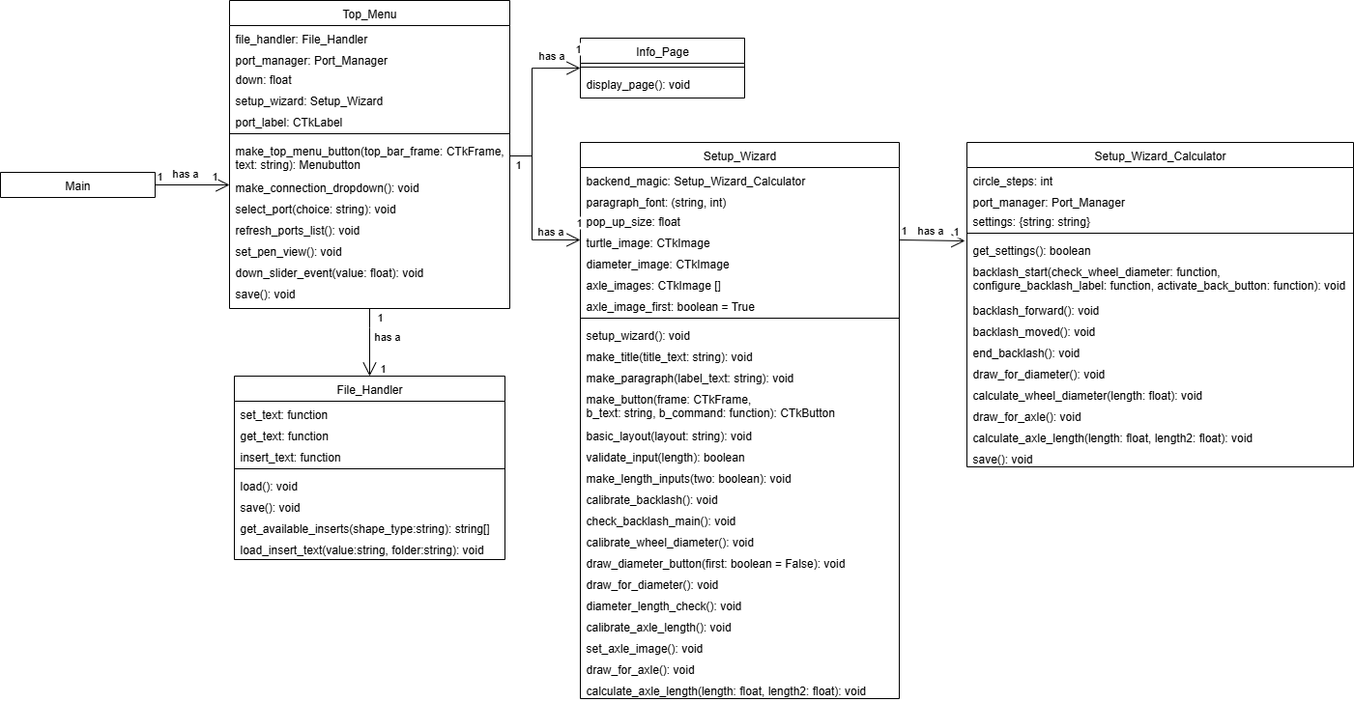

Figure - Top_Menu's classes

## Other Files

The project consists of eleven Python files. In addition to this, there are four other types of files used. Graphics files (Portable Network Graphics and ICO) for the graphics used within the application and for the application’s icon. Most of these files are found within the project’s graphics folder.

A Hypertext Markup Language (HTML) file is used for the information pages. This is so it can be edited and updated without the need to change the application’s code. It also has the benefit of not requiring the editor to be familiar with Python. This file contains information about the turtlebot as well as guidance on how to use the application, including code command information. This file can be found within the project’s html_info folder along with the images it uses.

The other file is a JSON file. This defines the application’s colour themes for CustomTkinter aspects. This theme is used by the application’s main class and defines the button colours and the top menu colour, among other elements. The file can be found within the main src folder.

Text files are found within the characters folder’s subfolders. These contain code that can be inserted into the code editor of the application for quick design building.

## Setup wizard

The setup wizard is designed so that each turtlebot can be configured to the correct dimensions. These dimensions can vary slightly, mainly due to shrinking as the plastic cools down once the parts are 3D printed. When the dimensions are slightly off, it can lead to results such as circles and squares not matching up or lines drawn not being the expected length. Although this is a minor issue with smaller drawings, when larger drawings are attempted, this error is significant.

To stop these problems, a setup wizard is produced so that a user can use it to work through various steps to calibrate the turtlebot to the correct dimensions and values. The dimensions in question are both wheels’ diameters and the distance between the two wheels (the axle length). It is also important to measure the backlash of the motors so they can be factored into any lines to be drawn.

By drawing shapes rather than using equipment to measure, the accuracy is increased. As an example, by getting the robot to draw a line twice the circumference of the wheels, then the percentage error from measuring equipment is halved. Drawing the shapes also means that a simple ruler can be used rather than specialist equipment (callipers).

The setup wizard works in three stages: working out the backlash, working out the wheels’ diameter and then working out the axle length (see Figure 15). After the dimensions are calibrated to a sufficient level, they are saved to the EEPROM. After this, the turtlebot loads these values to use within the main program upon future startups.

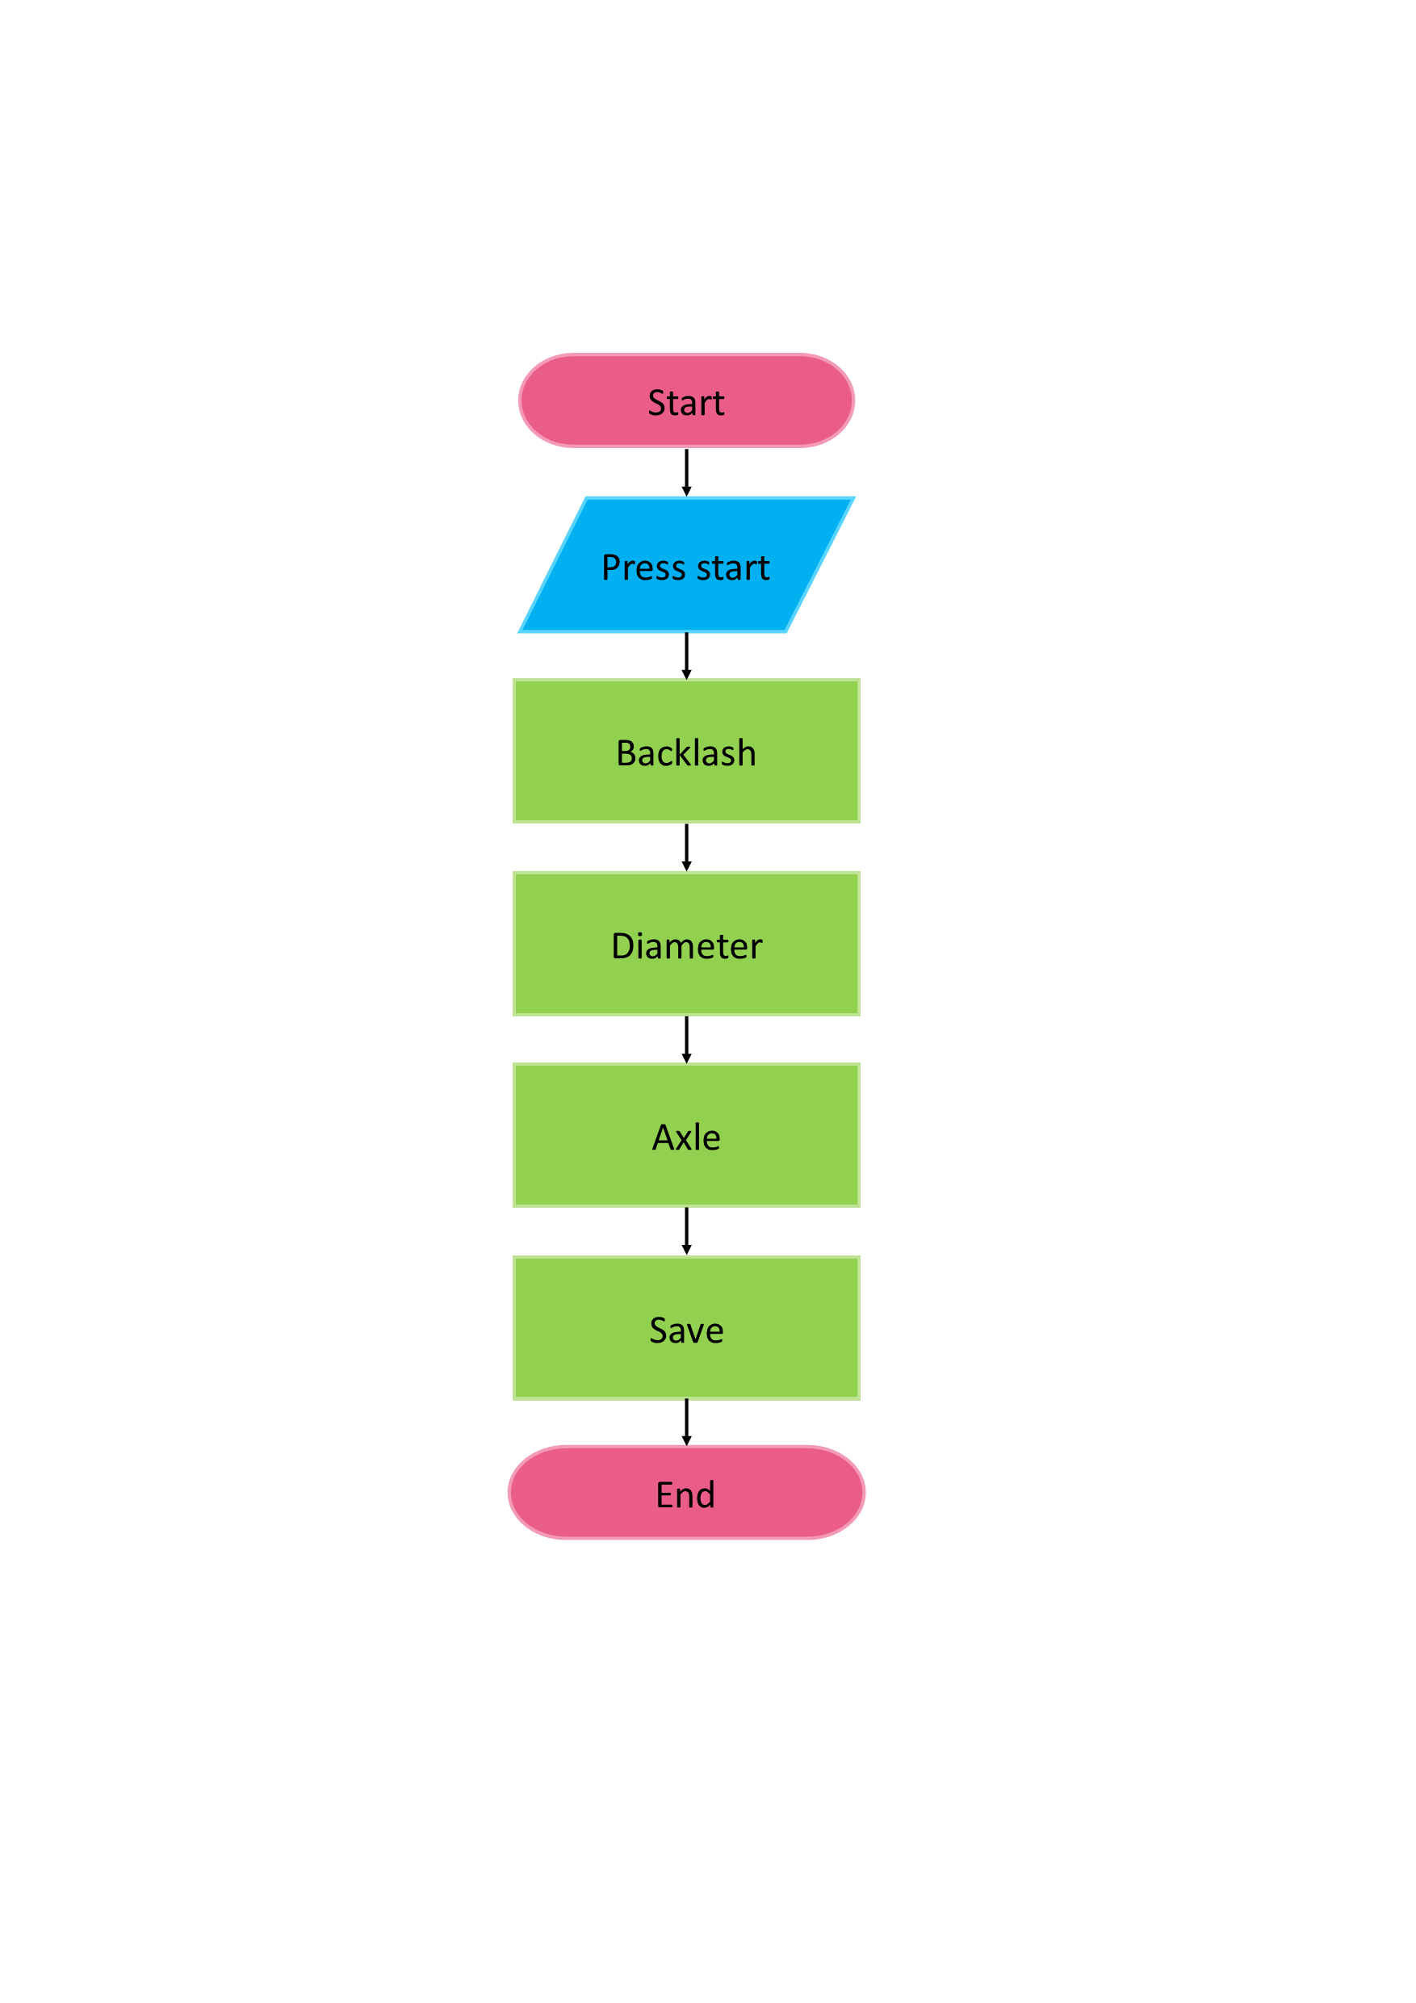

Figure - Setup wizard flow chart

### Backlash

The first calibrations are for the turtlebot’s backlash. This is done by having the turtlebot move backwards and then trying to move it forward. If the turtlebot moves, then the forward motion was more than the backlash value.

The wheels rotate by using geared motors. The gears have teeth which have a certain number of steps and rotation before the next tooth is moved to. This distance, measured in the number of steps in this case, is called the backlash. The backlash needs to be factored in when the motors first start moving after stopping or when the direction is reversed. The backlash being uncalibrated means that the lines drawn will always be wrong by the same amount, leading to high precision but low accuracy for the line wanted.

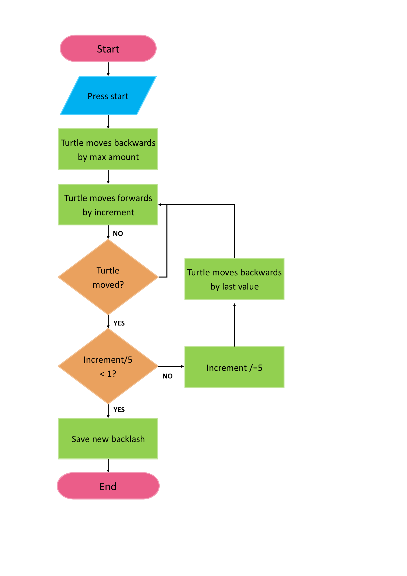

Figure - Setup wizard flow chart: Setting the backlash

As seen in Figure 16, the turtlebot originally moves back by a large number of steps. The increment starts as a fifth of the maximum amount. The turtle attempts to move forward by this amount.

If no forward movement occurs, then the turtle attempts to move forward by another increment amount. If movement does occur and a fifth of the increment is still an integer, then the increment becomes a fifth of itself. The turtlebot then moves backwards by the last value it moved forward by, and the moving forward process starts again.

If the increment becomes less than one, then the new backlash has been found and is saved. This is because the backlash is measured in the number of motor steps, which can only be a whole number. The backlash has also been found if none of the values make the turtlebot move forward, as the backlash must be the current maximum amount.

### Wheel diameter

The wheel diameter can be worked out based on whether a line drawn is the correct length. If the line drawn is shorter than expected, then the wheel diameters are smaller than expected. A longer line indicates that the diameters are larger than expected. We assume that the diameters of both wheels are equal. This is likely as they are printed at the same time, so they should have been affected equally by the factors. If this is not true, it becomes apparent during the line drawing test, though it cannot be fixed using the setup wizard.

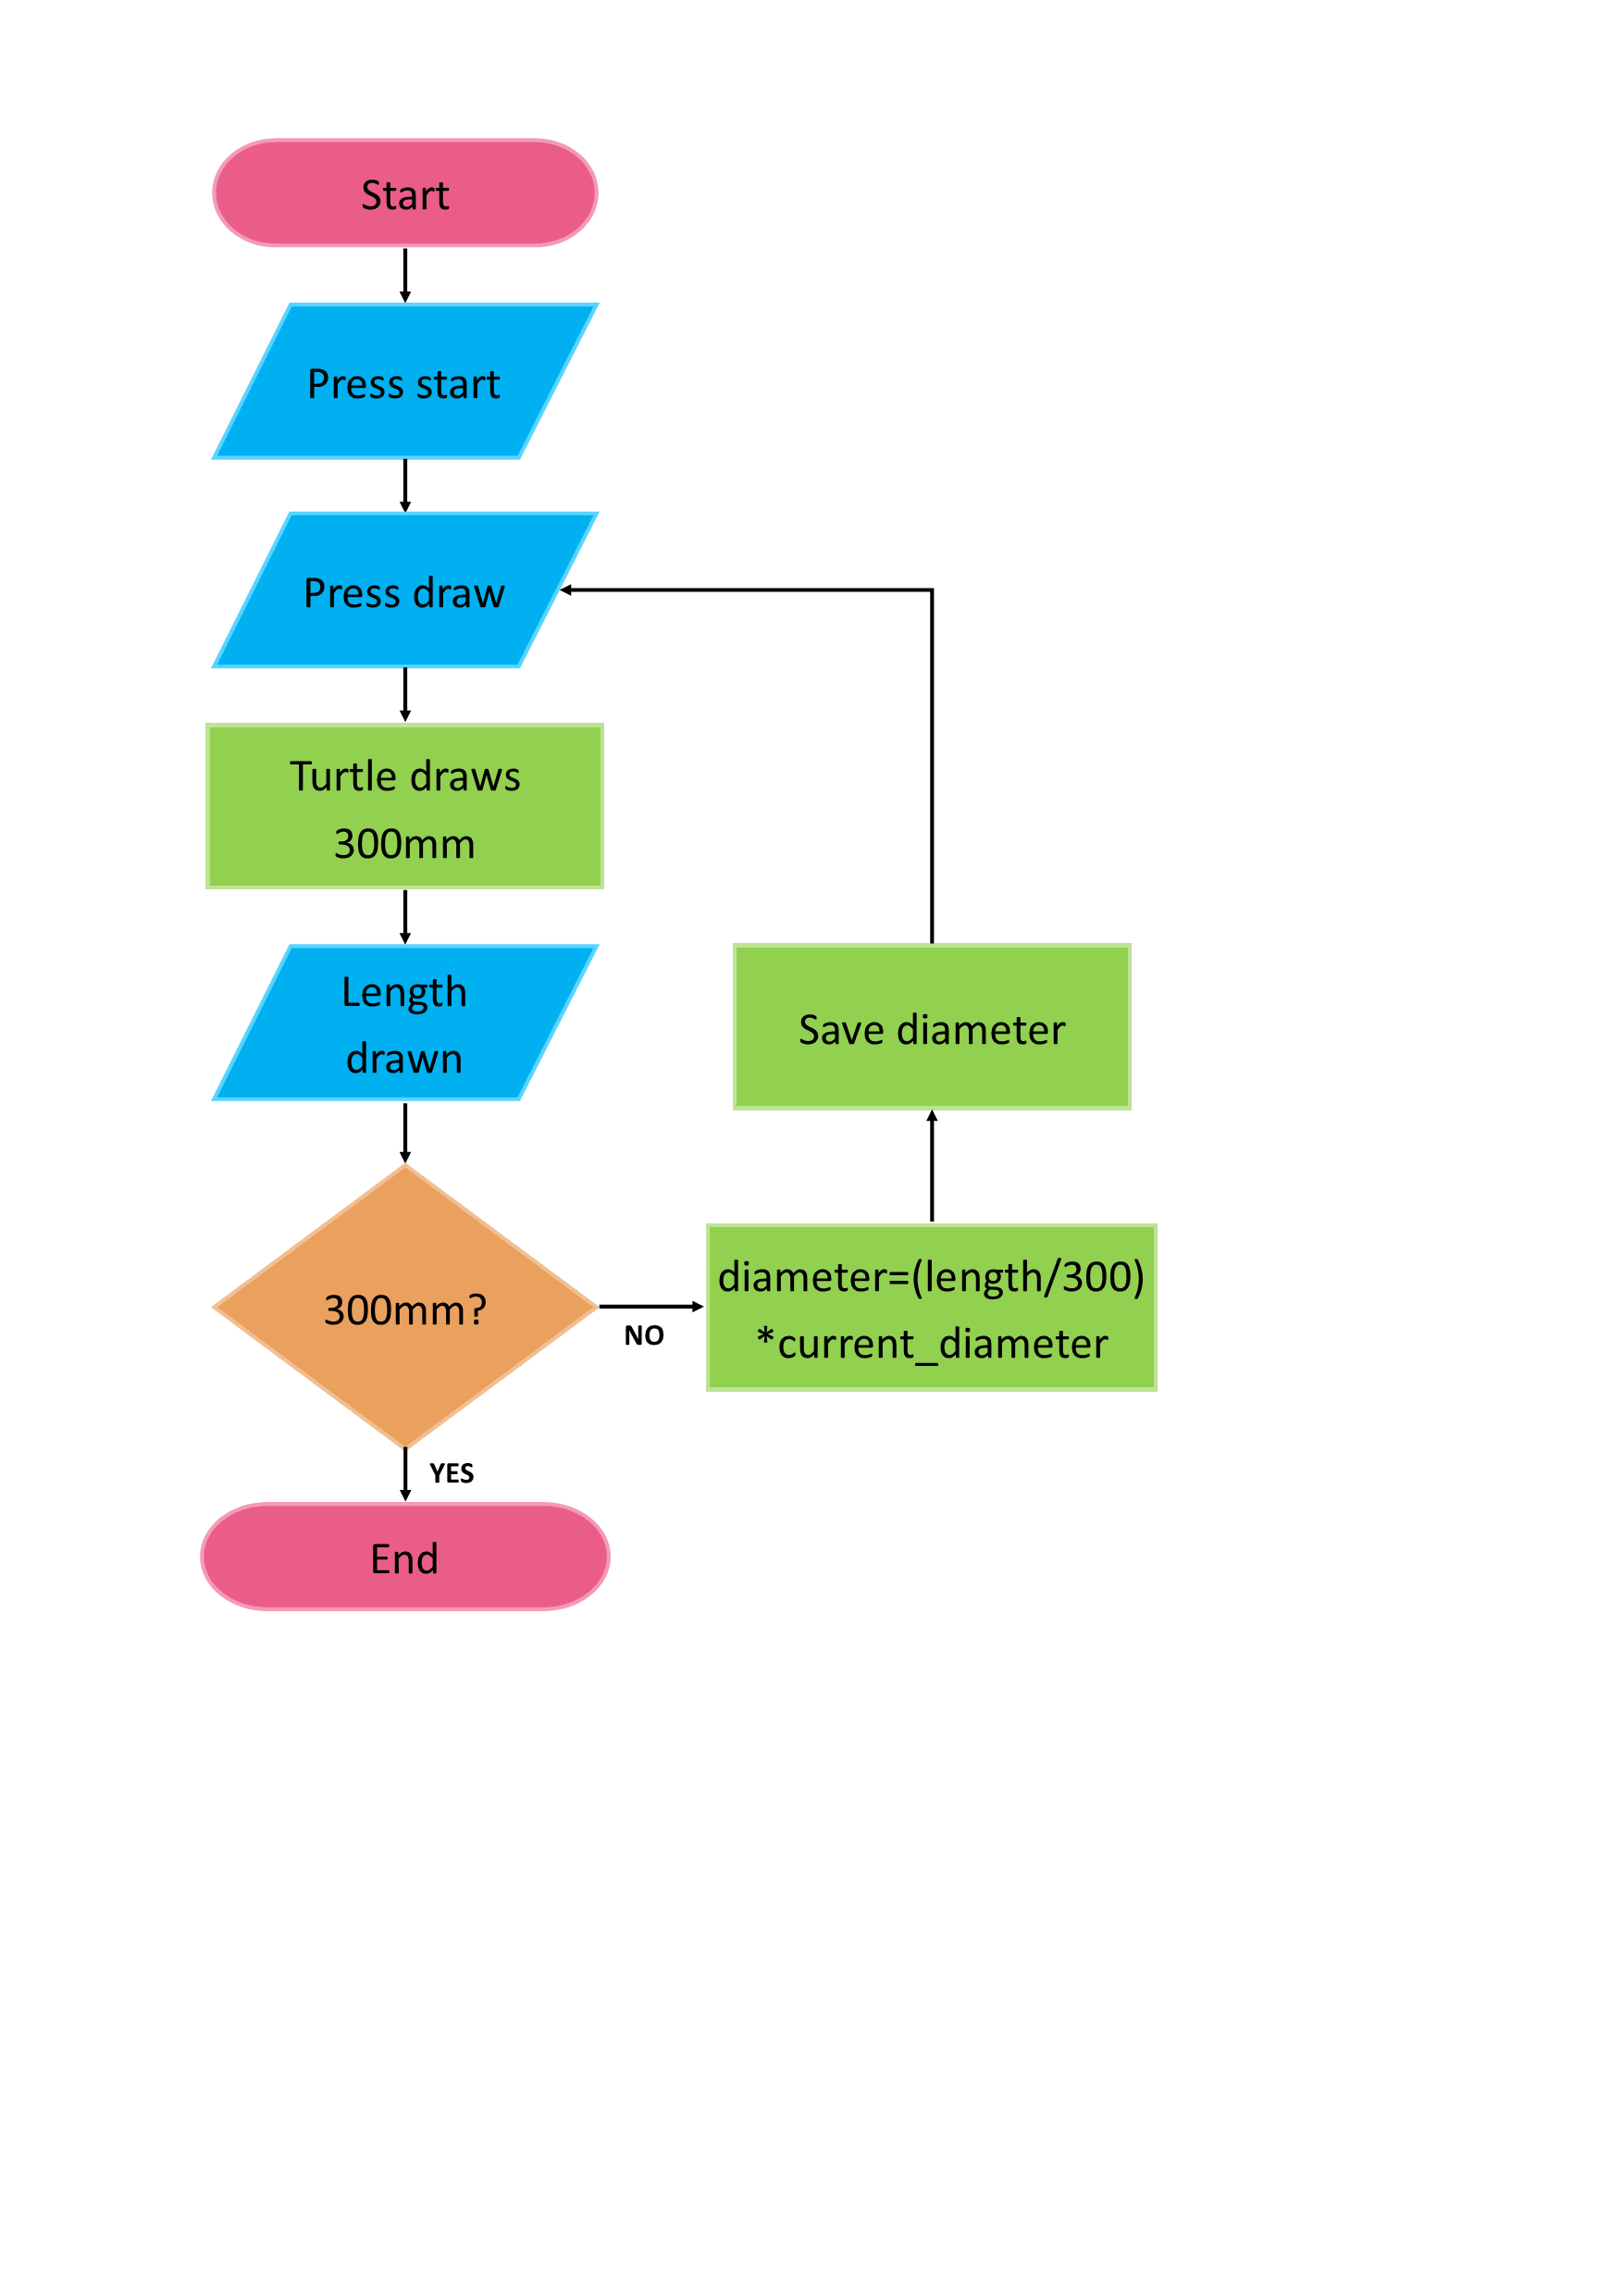

Figure - Setup wizard flow chart: Wheel diameters

As seen in Figure 17, the user prompts the turtle to draw a line that should then measure three hundred millimetres. The user then uses a ruler to measure the actual length of the line and inputs this value. If this value matches the expected value, then the diameters are already correct, so the wizard can move to the next step. If this value does not match, then the new diameters are calculated by multiplying the percentage of the expected length drawn by the expected diameter. This new diameter is saved, and the user can have the turtle draw the line again to see if the new diameter value is correct.

### Axle Length

Axle length becomes important when the turtlebot attempts turns. If the axle length is shorter than expected, then the turtlebot will under turn and vice versa. This leads to shapes not connecting properly, either forming a gap, an overlap, or a cross shape.

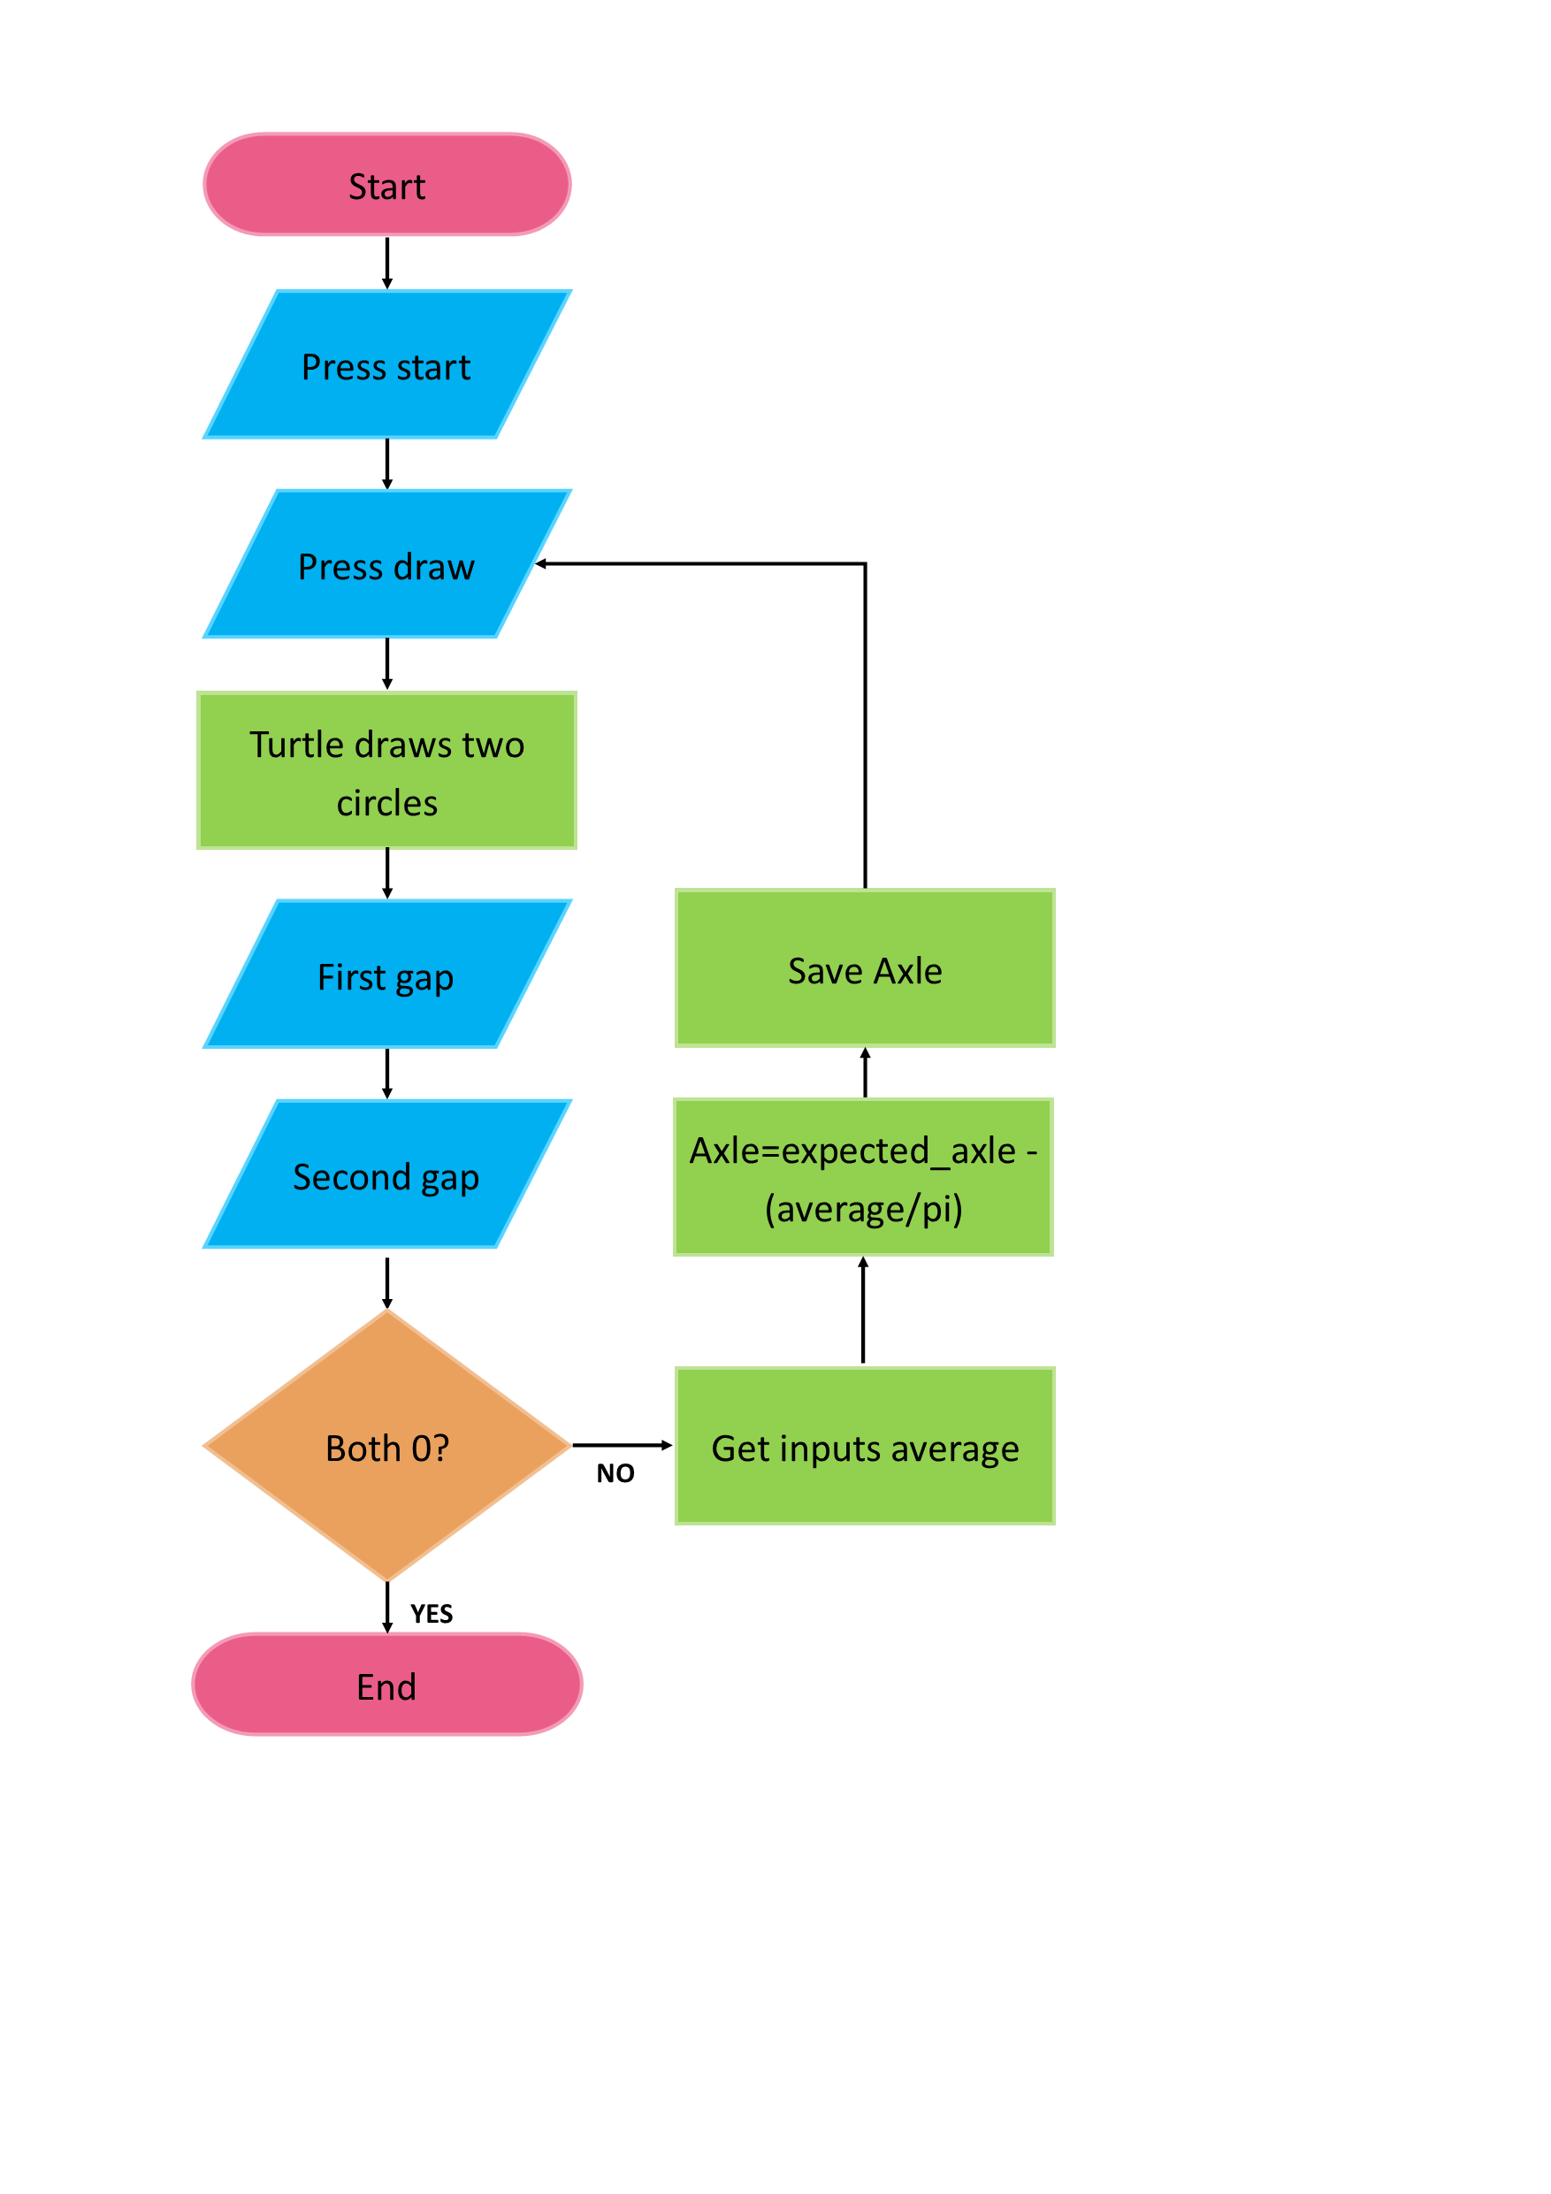

Figure - Setup wizard flow chart: Axle length

As seen in Figure 18, a sequence of steps is conducted to calibrate this. The turtlebot first draws two circles. Each circle uses one wheel as a pivot point while moving the other wheel to draw the circle. Each circle is calculated by working out how many wheel motor steps need to be taken to do a circle, which has a diameter of the axle length. The circumference of the circle with a diameter of axle length is divided by the circumference of a circle which has the diameter of a wheel. This is then multiplied by the number of steps in a full wheel rotation. An example of the circles drawn can be seen in Figure 19.

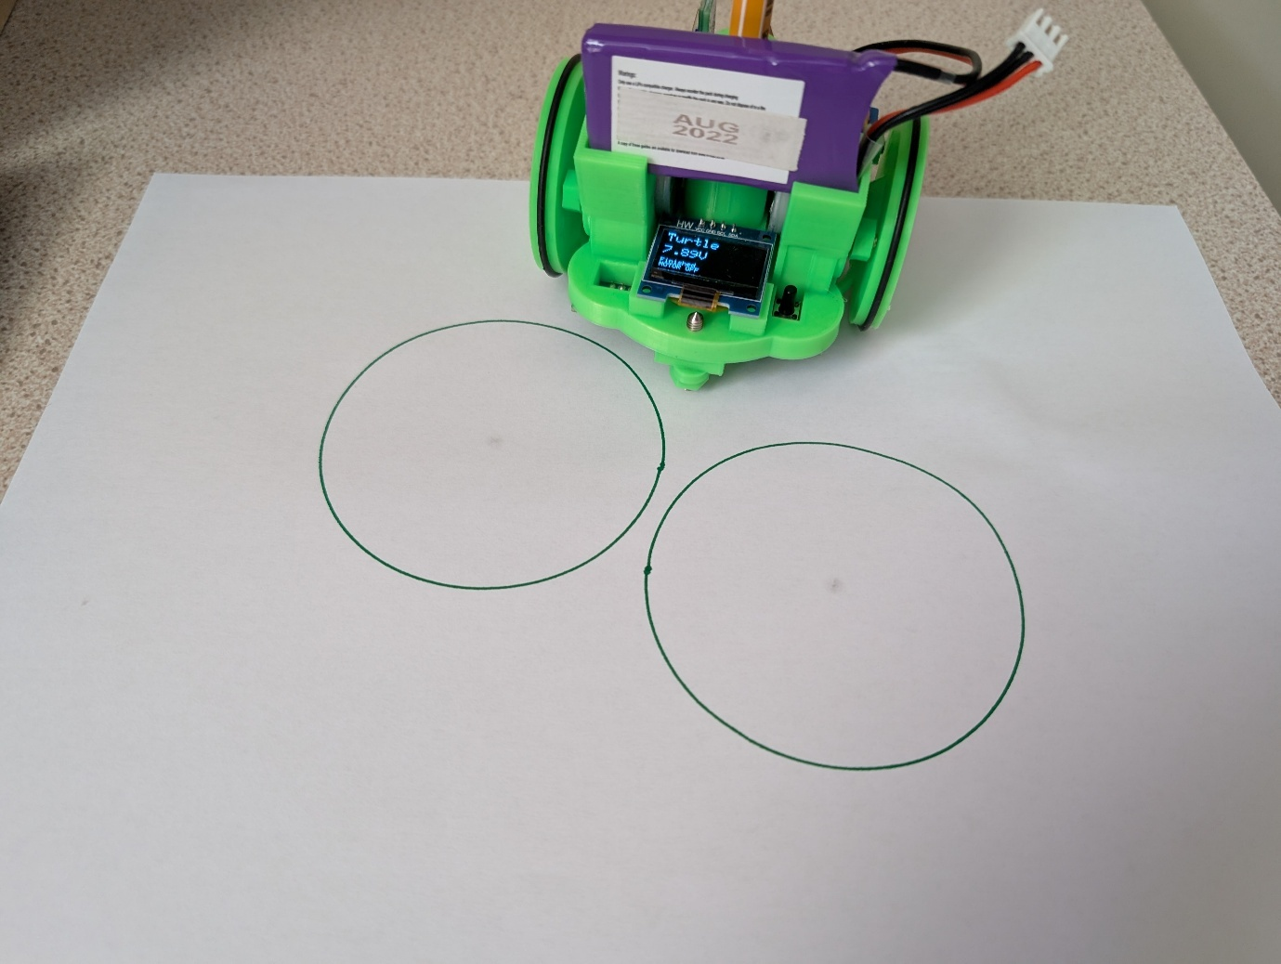

Figure - Setup wizard axle drawing

The user is then prompted to input two length values. If there is a gap in the circle, the user inputs the gap's size as a negative value. If there is an overlap, the user puts in how much by as a positive number. If the circles match up, then the user can input two zeros, in which case the setup wizard will move on to finishing. If there is a gap or overlap, the two inputted values are averaged. To get the new axle value, the expected axle value has the averaged value divided by pi subtracted from it. The user can then repeat the drawing process in hopes of seeing an improvement.

1. Implementation

## Introduction

Due to the nature of the project, many of the project’s aspects were developed in parallel. At the beginning of the project, there was no access to the turtlebot, so creating the code input and turtle simulation was the focus. As time progressed, a turtlebot was acquired. Once the basic functionality was achieved, additional features were added. This included the firmware being changed to support aspects such as the saving of turtlebot dimensions, which could then lead to a setup wizard being able to be created.

For the purpose of describing the implementation of the project, it has been broken up into blocks of functionality or of significance in implementing, with the addition of some key events.

## Basic functionality (pre-turtlebot)

After the spike work, multiple components existed that, if combined, would give a virtual turtle that could be moved via code that a user wrote. The components already made were a textbox with syntax highlighting, a virtual turtle simulation, a text box that showed error information and a run button. These were combined together resulting in three classes: a main class that ran the application, a turtle simulation class that handled the code and a code input class that created the textbox. After combining, the user could write their turtle code in, and when they pressed run, the simulation would run their code. The inputted code matched Python’s Turtle library.

A reset button for the turtle simulation and a clear all button for clearing the current program were then added. The application at this stage can be seen in Figure 10. The clear all button was later moved to be within the input box to make it easier to understand what it was clearing.

It was then found that some accidentally interesting results could be produced as the run button could be pressed repeatedly. This interrupted the current running code and replaced it with the new code. An extreme example of this can be seen in Figure 20. To fix this, code was added to disable the run button until the user’s program had finished running.

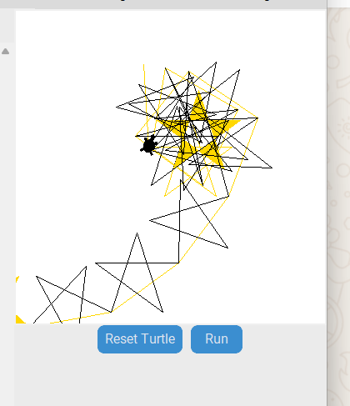

Figure - Extreme example of "spamming" the run button

## Responsive design

Responsive design was added to the project after the basic features were created so that the code boxes and simulation boxes always occupied half the screen each, even as the window size changed. Additionally, code was added to alter the run and stop button layout when it can no longer fit horizontally to display them vertically.

## The challenge of stopping a running program

Wanting to be able to pause or stop the user’s program impacted many of the design decisions of how to have the code run. Originally, the code was run by creating a thread for it and passing it into the exec function within this thread. In Python, there is no way to stop a thread. The closest you can get is to pause it for a given number of seconds. Given that a user does not want their program to unexpectedly start running again, an alternative solution was required.

Python has a multiprocessing library which works in an equivalent manner to its threading library but can be stopped or paused. This library cannot be used successfully with Tkinter as it causes the application to stop working. No other libraries were successful in achieving the desired result, so an alternative approach to running the user’s code was chosen.

### Taking a line-by-line approach

A new approach to handling the code was chosen. This was to process the code line by line for the turtle simulation, so that it could have a conditional statement saying whether it should be paused. If paused, it would not do the given action. This version also did not use threading.

Code was checked using Python’s compile function to check for syntax errors. It was then converted into a list of lines of code. These lines were then passed to the exec function one by one to be carried out and printed to the output box. Within this, an exception was put in to check for name errors that the original compile could not catch. An additional step was later added to convert each line to a turtlebot command to put into a separate list. This step used a dictionary to translate the commands.

Once additional language features were added, this method reduced in benefit. In order to process more complex code features, such as for loops, this resulted in creating a half-made compiler that could unroll the for loops to put them into the list correctly. Additional tweaks had to be done so the code could handle lines with just whitespace.

Later, it became apparent that variables would be useful, so they were introduced by saving their names and values in a dictionary. Before the code was run, the names were substituted for their values. A recursive function was then added to handle nested variables.

By choosing this method, the program could be stopped, however, it greatly reduced the code features that could be used, as each one had to be added in separately. This approach was therefore counterproductive for making a tool to help people learn to code, as features would be unnecessarily limited. A different approach was therefore required.

### Using an additional class approach

The code was changed so that it used a new class which knew how to handle each command. This version went back to putting the code into the exec function to run. The exec function handles the features of Python, so the code does not need to do it itself. The new class acts as an intermediary to the classes that handle communicating with the turtle simulation and the turtlebot. It processes and translates as needed to send the corresponding commands to each class. The functions within this class are the same functions that a user can type to control the turtle.

This version was far more streamlined than the previous version, with the same benefits as well as having all the normal Python features available, including being able to import modules so users can use features such as randomly generated numbers.

To stop the turtle, an else condition was added to the turtle simulation’s check if it was stopped. If triggered, an exception is raised, stopping the running program.

## Adding the turtlebot to the project

The first step of getting the turtlebot connected was to retrieve the available serial ports. This was originally done separately from the project for trialling purposes. Python’s serial library [14] was used to do this. A continuous read was then done on the port to read in incoming messages. This was done in preparation for getting the turtlebot, so there were some parts that later needed changes.

When the turtlebot was connected, the program managed to open the port successfully and read from it however, there were issues with connecting to the turtlebot via it. To establish the link, when a message containing “AT” is received, an “OKPC” message needs to be sent back. Originally, this was not working, but later it turned out that the command required a newline character at the end. The “OKPC\n” command does not return any message, so the system probes the connection by sending out hello messages until it receives an acknowledgement. After this, the port can be sent commands to control the turtlebot.

This code was then added in via the Port_Manager class. This class keeps track of the setup process to know whether the USB dongle is connected and whether the turtlebot is connected. These two connections are shown visibly on the application’s top bar using another class, so the user can also be aware.

Originally, these came with a refresh button to reset the connection, but this was later replaced with having the user be able to pick their chosen port.

The Port_Manager reads from the open port within a separate thread from the main program, so it can still run. The commands are sent within the main thread. Once the turtlebot had a connection established, the turtle graphics commands needed to be translated into turtlebot commands (which can be found in Appendix D). This was originally done with a dictionary to translate and then send the commands to the Port_Manager class, but was later changed to just directly send the commands to the class without the dictionary.

Later changes to the Port_Manager class included adding a buffer limit value so that the system waits until the turtlebot is likely to be able to hold the command in its buffer. This was done as when sending small, rapid commands, some were being lost due to the buffer overflowing. The system keeps track of how many commands it is waiting for acknowledgements for, and if this number is higher than the buffer allowance, then it waits before moving on to something else. This comes together, creating a sliding windows protocol.

## Moving the pen

Once the turtlebot was connected, a way to adjust the pen height was needed so the drawings would definitely be drawn and the pen would not be damaged when moving. To do this, a pop-up with a slider was made. When the slider moved, so did the pen. This is so the user can move it until it is just touching the paper underneath. The code for this is fairly simple. The issues arose with the turtlebot’s pen servo not always responding. This issue with the turtlebot was seemingly fixed by the time of project completion, as it now responds in the expected way.

## UI developments

After the main functionality of the application was achieved. The user interface was improved to be more appealing and have some standardisation. Before this, the application looked as it does in Figure 10.

### Theme and usability features

First, the colour green was decided as the main theme colour, given its association with turtles. A darker colour was picked for the top bar, which at this point consisted of two non-functioning standard buttons. The other buttons were changed to be a lighter green to contrast against the rest of the application.

Additional features were then added to the application. One of these features was the ability to change the font size of the text boxes of the application. Another was the addition of having default code in the code text box. Both of these changes were done to increase the versatility of the application and help users get started.

Later, the code was changed so it used a JSON file to define its CustomTkinter component’s theme. This was used to set the used components' default colour to green, so it does not need to be defined for each button, only overwritten for special components. This file was taken and altered from the official CustomTkinter documentation [15] to meet the desired theme.

### Graphics

All graphics were made using GIMP [16]. Microsoft PowerPoint was additionally used for producing the abstracted turtlebot image for the setup wizard.

#### Creating the logo

The application’s logo was made using GIMP. It was originally made horizontally using Python’s Turtle as a rough visual guide for proportions. This was then turned into a blockier version, as seen in Figure 21.

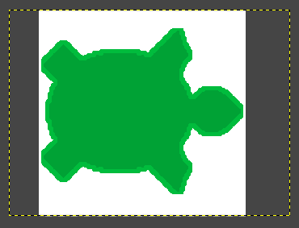

Figure -Horizontal original application logo

The logo was then rotated to be diagonal to fill the square space better. It was then also smoothed out further. There is the option to have a green edge or a white one, depending on use. The application uses the green one, and the user manual uses the white outline. The final GIMP file design can be seen in Figure 22.

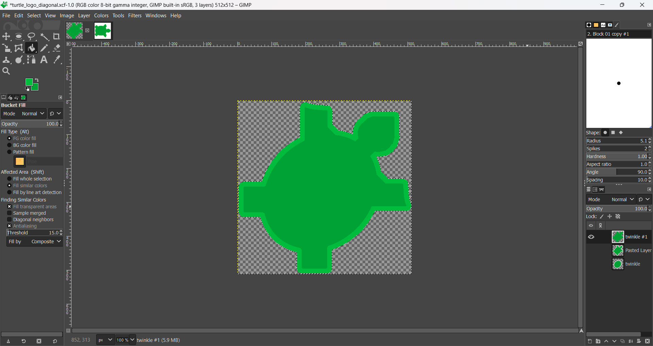

Figure - Final logo design

#### Creating the setup wizard graphics

Multiple graphics were created for this. The path drawings were made using GIMP’s pencil tool. The abstract turtlebot was a little more complicated.

A picture of the top of the turtlebot was taken, see Figure 23. Key shapes were turned into blocks by overlaying them with PowerPoint shapes, see Figure 24. The shapes were then simplified further, and outlines were added with GIMP. The final result can be seen in Figure 25. This image was then added to other images to demonstrate how the turtlebot would move during the setup wizard.

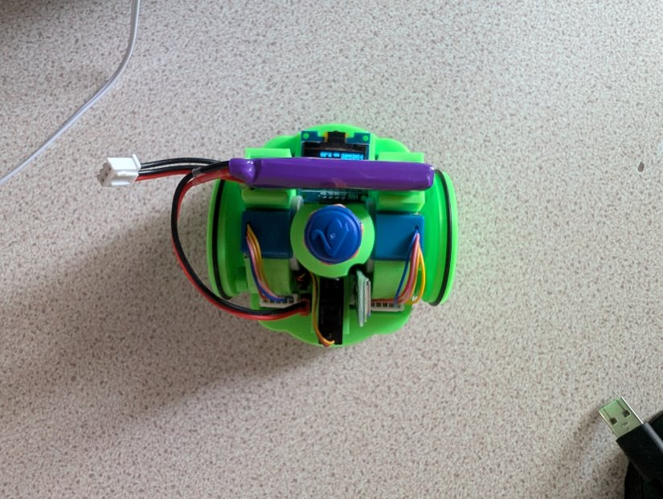

Figure -Original turtlebot bird’s eye view

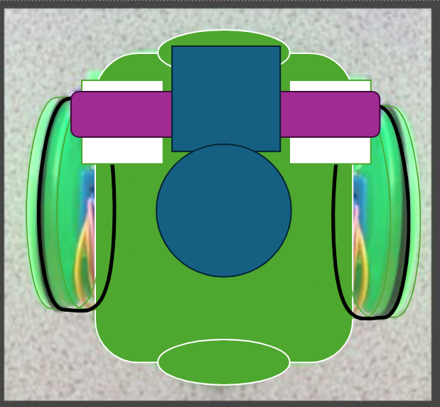

Figure -Picture with PowerPoint blocks overlaid

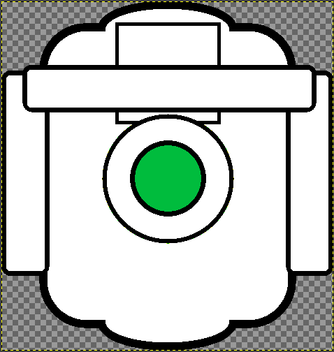

Figure - Abstract turtlebot GIMP image

## The creation of the top menu

### Menu buttons

Buttons were required to access the additional functions of the application. These would preferably need to be dropdowns so that the application was not cluttered with these buttons. The additional challenge was to try to check the connection states on the same line as the dropdown buttons.

Originally, Tkinter’s menu bars were investigated, however, these only allowed having menu buttons on them, and other components would appear below the bar, and two bars would not be space-efficient. The menu buttons by themselves had potential, though.

Tkinter Menubuttons can be used as normal buttons or contain submenus with normal options or radio button options. These Menubuttons were used to construct a menu bar on a normal frame, which allowed both the buttons and the connection states to be displayed upon it. The first tackled part of the menu was getting the font size of the code textbox to be able to be changed using it.

### Font size issues

The picking of the font size used radio buttons. A loop was attempted for adding buttons for each size in a list of possible sizes. This originally had issues, as it always carried out the last option in the menu despite picking another size. This turned out to be an issue with lambda use. The code originally said “lambda: change_textsize(i)” and needed to say “lambda i=i: change_textsize(i)”. Once this fix was done, the changing of font size behaved correctly.

### Saving and loading to and from files

The File_Handler class was introduced, whose methods are called when saving or loading a file. They both use CustomTkinter’s filedialog module, which has classes to handle opening a save-as file dialogue or opening a file dialogue. Both of these can be used to get a filename, which can then be used to open the file and read or write to it as needed. For saving the code, the code within the code textbox is passed in as a parameter. For loading, the function has access to the method to set the code textbox’s text.

### Insert premade designs

To provide the option of inserting simple premade shapes, the File_Handler class had two new functions added. One to find the available text files within a specified folder name, and one for handling the reading from a chosen file and inserting the contents. The list of available files is added to the menu under the insert option, under submenus of their folder name. This was done dynamically so that additional shapes and alphanumeric options can be added as desired.

### HTML pages

Details about the development of the HTML pages can be found within HTML pages section of the Spike work chapter. The project ended up using tkhtmlview’s HTMLScrolledText widget to pack the HTML page into a window. The user can use this to scroll through the page contents to find what they are looking for.

### Picking a port

Originally, the application worked by always trying to open the first port in the list. This is not always the desired port, however, so a way to pick the port was needed. This was done by introducing a pop-up that contains a dropdown of the port options for the user to select from. It was originally hoped that the list could change in real-time to reflect the current ports available, but that would, unfortunately, require putting this in a thread, and Tkinter will not work with a thread outside of the main one. Instead, a refresh button was introduced so the user can prompt an update of the dropdown themselves. This new method allowed a port to be picked and opened. At the time, however, only one serial port was available to test on.

During the next project meeting, a second turtlebot with its own USB dongle was used to test this new feature of swapping between ports. This showed that the swapping of ports was not working correctly. After three hours of trying to find the issue, it became apparent that the method to set the port was not calling the method to actually open the new port. Once opening the new port was fixed, swapping ports worked successfully. After the meeting, the Port_Manager class that handled the ports was altered so that when a new port is selected, the old one is closed, the new port is opened, and a thread is started to read from it. The class was also generally streamlined to reduce code duplication so that any further issues could be more easily identified. A label was then added to the top bar to show which port was opened last, done largely because it proved easy to forget which port was attempted to be opened last while working during the meeting.

## Open day tweaks

Since the application was in a state where it could be tried out by users, it was taken to an open day for some informal testing. This meant it could be seen how it performed on the lab computers and with users.

It was also a good way to see if any additional features would be desirable. Some of these additional features have already been described, such as having a theme for consistency and having the ability to insert shapes. The difference between the text size for the code textbox and the output text was more obvious on the bigger screens, so it was decided to have changing the font size change the size of both instead of just for the code textbox.

One of the prospective students attempted to use variables and import libraries, so it became apparent that, ideally, the application should be changed to be able to handle this, so it was. It also became apparent that an undo option on the code textbox was needed, which was implemented by setting the ScrolledText widget’s parameter of undo to true.

The virtual turtle was found to commonly run off the simulation screen, which was undesirable, so a way to fix this was needed. Originally, it was planned to do this with scrollbars, though this proved unfruitful.

The open day also proved a good opportunity to see how the application ran on a Mac device. Here, it was found that the menu buttons displayed as white (the default on Mac) despite being specified to be green. This led to a minor change to specify that if the platform was a Mac one, then the writing should be green instead of white, so it was legible. Loading a file was also found not to work on Mac. This turned out to be a difference in whether the operating system can handle looking for any text file without the asterisk wildcard character. Windows can, whilst Mac can not. This was changed so it worked for both operating systems.

## Scaling the turtle

A way needed to be found to have the virtual turtle be visible or at least findable on the screen at all times. This presented some challenges due to how turtle graphics is designed. The turtle works on a coordinate system, but has no information about the borders of its screen or the canvas it is on. Originally, the plan was to introduce scrolling bars so the turtle could still be found. This had its own issues, as they could not be made dynamically as the turtle moved in that direction, as there was no way of keeping track of where the turtle travelled. Having a static, bigger canvas with scrollbars to view it would result in still having the same problem as a smaller one, resulting in just having the turtle draw a bit more of the line first.

The decision was made to scale the turtle’s drawings based on the space available. If the drawing were to result in leaving the canvas, then the line would be scaled to fit the canvas. The achieve this, the lines related to movement were all collected before drawing to work out how much overall space the shape drawn would require. The lines were fed into an algorithm to do this.

First, the available space is worked out based on roughly where the turtle is and the canvas size. The exact location of the turtle cannot be determined as its coordinates will be (0,0), but where this appears on the canvas can change. This is mostly fixed, though it is the source of the issue when scaling does not work.

The amount the turtle moves in the North, East, South, and West directions are tracked so the scale needed for each direction can be calculated. The angle the turtle is facing is also tracked.

For each line, the algorithm determines what type of command it is.

* If it is a forward command, it works out the vertical and horizontal components of its distance that is travelled based on the current angle. These distances are added to the corresponding directions moved in.
* If it is a curve command, it is first processed into lines, then follows the same process as a forward command. More detail is given later in the chapter.
* If it is a right or left command, then the current angle is altered to match the angle the turtle would now be facing out of 360°.

Once all the lines have been processed, the scale the turtle would have to be to fit within each particular direction is calculated based on the available space. The smallest of these scales is then set to the current scale. When drawing, this scale is used to shrink each line before drawing, as well as shrinking the turtle to match.

## Setup wizard

### The calculations

Before the setup wizard could be created, the shapes it would draw had to be decided. To work out the axle length of the turtlebot based on a shape, the wheel diameters needed to be known. Therefore, the diameters needed to be worked out before the axle length. It was decided to assume that both wheels had the same diameter, which is likely if they are printed at the same time. Various shapes were tried out for working out the axle length. In the end the simplest approach was given by the project’s supervisor along with the equations to work out the configurations based upon the shapes drawn. This approach worked by working out the percentage error of the given shape to then adjust the value that was expected.

The original calculation given for working out the correct axle length was not correct. This became apparent when running the program, as the circles drawn became worse rather than better. The equation given was:

$Actual axle= Expected axle*\frac{Circumference of circle with axle as radius - overlap}{Circumference of circle with axle as radius}$

This is slightly incorrect due to the pen being in the middle of the turtlebot, so the circle drawn has a radius of half the axle length and a diameter of axle length. This difference can be seen in Figure 26 where the solid line is where the pen draws, and the dashed line is where the wheels move.

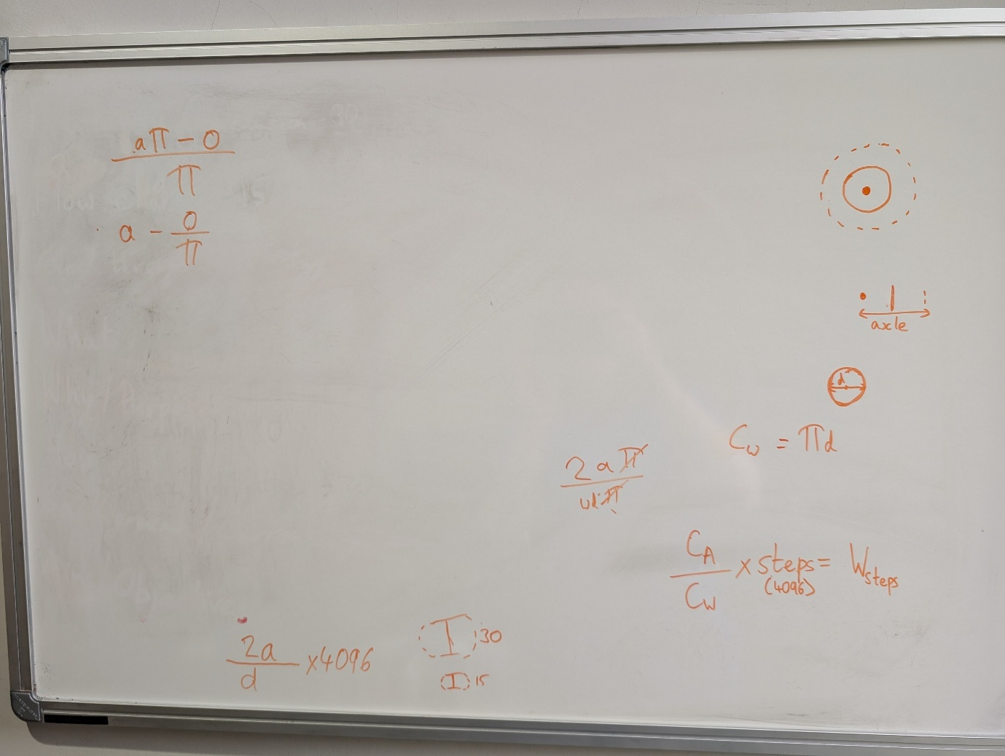

Figure - Axle and pen paths for a circle

This changes the equation to:

$$Actual axle= Expected axle*\frac{Circumference of circle with axle as diameter - overlap}{Circumference of circle with axle as diameter}$$

Which can be simplified to:

$Actual axle= Expected axle-\frac{average gap}{π}$

This change led to the circles meeting up when corrected by the equation.

### The wizard

The wizard was developed incrementally by each calibration stage. First, a pop-up was made that attempted to send a get command to the turtlebot to get its current calibrations. The pop-up also needed to handle prompting the user if no turtlebot was connected. The pop-up was first made to be functional, then changed to be more user-friendly with images for guidance.

#### Backlash

After that, the next stage was working on the backlash, which took some trial and error. Variables were made to hold the maximum value that the backlash could be, the minimum value that it could be, the value currently being trialled, and the increments between values being trialled.

Two buttons were introduced to handle user input. The no difference button informs the system that the turtlebot did not move, meaning that the backlash must be higher than the current value. The moved button informs the system that the turtlebot moved, indicating that the backlash is equal to or less than the current value.

This then works iteratively by making the current value the new maximum value, and the minimum value the previously tried value. The increment is then reduced, and the moving process starts again. The trial and error came into play, getting this concept correct. It later had to be tweaked as the code was written with the assumption that the backlash was measured in millimetres instead of steps. This meant that the command for moving forward had to be changed to a lowercase f instead of an uppercase one. Steps are also integers, so the values and increments needed to be as well. The process was changed to stop when increments would no longer be in integers or if the value had already been found.

#### Other calibrations

The other stages of the setup wizard were fairly straightforward to produce. They simply have a view with a picture and a button to draw the shape, then swap to a view with text inputs. If the correct value is not given, they calculate the needed change, then swap back to the draw view. If the correct value is given, then they move to the next stage.

Both the axle and wheel diameter values were found to need to be rounded. Otherwise, they were too large for the double size that the turtlebot can handle, leading to a “What?” message with the leftover numbers since they were split from the rest of the command.

#### Crashing

The setup wizard was known to sometimes crash at different points, depending on how many repeats of the stages were done. If it had not before, the application always crashed during the saving process, though it managed to save the configurations first. Originally, this was assumed to be related to the order the commands were sent and UI changes were carried out. Changing this order did not make a difference.

Later, it was realised that the configuration settings commands do not send acknowledgements back. This meant that the sliding windows system would not work for configuration commands and resulted in an infinite wait for acknowledgements. The function that was used to send these particular commands was changed so they did not use the sliding windows and just sent the command. After this change, the system no longer crashed.

## Curves

Near the end of the project, a new movement was introduced. This was to allow the turtlebot to draw a smooth curve. The parameters are the arc length desired and the arc’s angle. To add this to the application, a new function was added to the User_Turtle class called curve, which took in the values. A turtle graphics corresponding function then needed to be found, the closest of which was the circle function, which has parameters of the radius of the circle and the angle. This meant that the radius has to be first calculated from the arc length and the angle, then passed to the turtle graphics function.

Once the new command was working, the scaling needed to be worked out to keep it on the screen. To do this, the amount the curve would go in each direction was needed.

The angle of the curve is split into 90° segments. Each segment is then converted into a line, which is the arc’s chord, to work out how far it travels, and the angle of that line is calculated. The normal scaling for forward motion is then done to convert it into vertical and horizontal components.

1. Testing

## How testing was approached

Testing was carried out via a manual testing table, which can be found in Appendix E. Manual testing was chosen due to its suitability given the user interface nature of the project, as well as the ability to monitor that the turtlebot did the correct action.

All features of the application were tested. These include the code inputs that the user could attempt, and running the turtle. The additional features are also included. These include the setup wizard process.

Automated unit testing was considered. However, there are very few occasions when they are suitable for use in the project, so testing was done solely using manual testing. Very few of the functions within the application return anything, and when they do, it is generally a UI element which wouldn’t be suitable for Python’s unit testing. Instead, it is more sensible to manually test by seeing if it shows on the application correctly.

## Conclusion

As can be seen in Appendix E, all of the tests passed without issue.

1. Packaging

## Packaging

The application was packaged using the Auto Py to Exe library [17]. This was done to turn the project into a runnable executable with a directory structure. The directory is a requirement so that the additional files can be located. These files are the HTML file, the theme file, the graphics files and the insert files and all their respective directory structures.

One benefit of this is that the HTML file can be updated without having to repackage the application. Once the application is packaged, it can be compressed and distributed to the devices it is required on.

To turn the project into an executable Auto Py to Exe was launched. From here, a window is opened where the location of the main.py file can be specified along with the application's name and icon image (found in the graphics folder). The project's files and folders other than the Python ones need to be specified so they are included in the project. These folders are the characters, graphics, and html_info folders with the addition of the turtlebot_theme.json file.

These configurations can be imported from the exe_config.json file in the project’s directory. The project can then be converted. Once done, the earlier specified folders and file need to be taken out of the _internal folder and put into the project folder.

## Using the application

The application has been primarily designed for use on Windows, and this will produce the best results. The application will work on macOS, but Tkinter is not as well designed for it, so it makes components such as the top menu buttons display differently. The application has not been tested on Linux, so using it may lead to unexpected results.

The device used will require a USB port or another port with a converter for USB attached if the turtlebot is to be used. This is so the USB dongle for the Bluetooth connection can be plugged in.

A user manual has been created to provide guidance on using the application. This can be found within the project’s folder, and some of it has been included in Appendix F.

1. Critical Evaluation

The aims and objectives of the project were met. Although there are places for improvement and areas where the application may be fallible, the overall application is fully usable. Overall, the project worked to a good schedule, finishing within a timely manner and allowing for additional features to be developed to make the project more complete, providing features for a greater range of uses.

## Project strengths

If the application is given to a user, they will be able to achieve the desired objective of the application. They will be able to type code. This code will have syntax highlighting whilst it is written, and feedback on errors can be given when a user attempts to run their program. The user can run their program and see their code execute via a virtual turtle that stays on the screen. They can also connect to the turtlebot and have the commands carried out on that. This means that the main objectives of the project have been met. When taken to the open day, those who used the application managed to code and use the program without directions, suggesting that the layout is intuitive enough.

Beyond the base features, the user has access to many additional features to improve their experience and increase the range of things they can do. They can save and load their work. They can quickly build designs by inserting premade shapes either to get started or to quickly produce a demonstration. They can access more information from a dynamic source so that the information can be altered without having to change the application’s source code. The smaller features go on, coming together to make a useful application.

There is a setup wizard created to calibrate the turtlebot so more precise drawings can be achieved, which, importantly, works to achieve better drawings.

The choices for libraries came together well, proving to be the right choices after the spike work to result in a cohesive application.

The step-by-step approach to tackling features for this project worked successfully to create the application. This also worked well for handling the many additional features that were added to the project. These additions also included additional turtlebot functions that could be added easily due to the project’s structure. If the project were redone, the same approach would be taken.

## Project Weaknesses

There are some known weaknesses of the project, and it would not be surprising if there were some others. These can be found within the scaling of the virtual turtle and setup wizard. Both of these features required coming back to and debugging or altering multiple times. Therefore, it would be entirely possible for them not to be perfect and likely to have issues. The scaling is especially vulnerable to this.

The weaknesses of the system are all fairly minor. One of these is that the connections display can throw warnings due to trying to change Tkinter elements outside of the main thread. This does not stop the application from performing the desired function, but it is not ideal, though no alternative could be found that did not stop the application.

The turtle simulation is sometimes scaled down further than necessary, resulting in the shapes being drawn being quite small.

The picking of ports would benefit from having fewer steps, considering that it is an action that is regularly done. Currently, it takes four steps: click settings, click Select Port, click on the dropdown and then click on the desired port. Considering the frequency that these actions need to be done, it may be better to make selecting the port more accessible, such as having the dropdown replace the port label on the top bar.

## Future Work

The initial plans for the application's future work after the project were tackled within the project's timeline. There are, however, some places that would benefit from additional work and refinement. Some other features could be added, though it is a balance between additional features and keeping the application simple.

### Improvements to existing features

The setup wizard would benefit from having the option to go back to redo each stage. This could be done fairly simply with a back button that goes back to the previous view by calling the function that makes it.

Selecting a port could be streamlined, as mentioned within the weaknesses section. If the suggestion for it is taken, then the label can be replaced with the port dropdown. A refresh button would also need to be added to the top menu. It is recommended that this be done with a symbol rather than a word to make it clear that it is not one of the submenus.

The code textbox would benefit from auto-indenting for when code, such as for loops, is written as it is generally expected in most similar environments.

### Additional features

#### Timeout

A timeout feature for sending commands to the turtlebot would be useful. This would be beneficial so the system could report to the user when a command fails or takes longer than expected. This would require starting a timer for each command sent and stopping it once the command's corresponding acknowledgement is received. If a sensible amount of time had passed, the system would throw an exception with what command that had failed to respond to. This exception would then need to be displayed to the user.

The timers would likely need to be monitored on a separate thread to keep checking them every second or so.

Each command would need to be mapped to the expected acknowledgement number. The number of timers could be up to the buffer amount. Once the command had been acknowledged, the command number and timer could be discarded.

#### SVGs

Having the application be able to load in SVG files and run them straight on the turtlebot was discussed. This would be to create complex designs, such as logos and signs. To do this, an option would need to be added to the file submenu on the top menu. Then the SVG-specific processing would need to be done.

1. Conclusion

Overall, the creation of the application to support the turtlebot was successful. All requirements were met along with some additional ones. The application can be used to develop programs either by a learner or someone looking to demonstrate the turtlebot and software. The application can additionally be used for setting up the turtlebot.

The system design works well for making additions to as proved within the project's implementation, being relatively smooth. This includes the additions of extra turtlebot movement options, as seen with adding the curve function. The final application can also be easily packaged and distributed for use without the need for additional installations, and when tested, it passed all tests.

Some areas may benefit from refining, such as the setup wizard and port selection, but the main features will provide a good experience, and all features are usable.

The application achieves its purpose and more besides, allowing the user to develop code to control the turtlebot. It is the hope that when used, it is enjoyed as much as its turtle predecessors, whilst helping to develop its users’ coding skills.

# References

[1] S. Papert, “A COMPUTER LABORATORY FOR ELEMENTARY SCHOOLS,” MASSACHUSETTS INSTITUTE OF TECHNOLOGY A.I. LABORATORY, Oct. 1971. Accessed: Jul. 30, 2025. [Online]. Available: <http://hdl.handle.net/1721.1/5834>

[2] C. Solomon *et al.*, “History of Logo,” *Proceedings of the ACM on Programming Languages*, vol. 4, no. HOPL, pp. 1–66, Jun. 2020, doi: <https://doi.org/10.1145/3386329>.

[3] Python, “turtle — Turtle graphics — Python 3.7.4 documentation,” *Python.org*, 2019. <https://docs.python.org/3/library/turtle.html> (accessed Aug. 06, 2025).

[4] C. Solomon, “Logo Things,” logothings, 2016. <https://logothings.github.io/logothings/Home.html#HOME> (accessed Aug. 06, 2025).

[5] S. Papert and C. Solomon, “TWENTY THINGS TO DO WITH A COMPUTER,” pp. 1–5, Jun. 1971. Accessed: Aug. 06, 2025. [Online]. Available: <https://dspace.mit.edu/bitstream/handle/1721.1/5836/AIM-248.pdf?sequence=2&isAllowed=y>

[6] P. Boytchev, “About,” Uni-sofia.bg, 2015. <https://pavel.it.fmi.uni-sofia.bg/logotree/about.html> (accessed Aug. 06, 2025).

[7] Scratch, “Scratch - Imagine, Program, Share,” *Scratch*, 2007. <https://scratch.mit.edu/> (accessed Aug. 07, 2025).

[8] N. Fazakerley, “BeebControl’s BBC Buggy Page,” Riscy.uk, 2025. <http://www.riscy.uk/beebcontrol/buggies/bbc_buggy/index.html> (accessed Aug. 06, 2025).

[9] The Centre for Computing History “Valiant Turtle - Peripheral - Computing History,” *Computinghistory.org.uk*, 2025. <https://www.computinghistory.org.uk/det/39597/Valiant-Turtle/> (accessed Aug. 07, 2025).

[10] “LEGO® TC logo.” Accessed: Aug. 06, 2025. [Online]. Available: <https://ia802903.us.archive.org/4/items/lego-tc-logo-reference-guide/lego-tc-logo-reference-guide.pdf>

[11] “LEGO® MINDSTORMS® About | Official LEGO® Shop GB,” *www.lego.com*. <https://www.lego.com/en-gb/themes/mindstorms/about> (accessed Aug. 07, 2025).

[12] E. Ackerman, “TurtleBot Inventors Tell Us Everything About the Robot,” *IEEE Spectrum*, Mar. 26, 2013. <https://spectrum.ieee.org/interview-turtlebot-inventors-tell-us-everything-about-the-robot> (accessed Aug. 07, 2025).

[13] TurtleBot, “TurtleBot,” *www.turtlebot.com*. <https://www.turtlebot.com/> (accessed Aug. 07, 2025).

[14] Chris Liechti, “pySerial — pySerial 3.4 documentation,” *Readthedocs.io*, 2016. <https://pyserial.readthedocs.io/en/latest/pyserial.html> (accessed Aug. 26, 2025).

[15] T. Schimansky, “Color and Themes | CustomTkinter,” *Tomschimansky.com*, 2025. <https://customtkinter.tomschimansky.com/documentation/color> (accessed Aug. 08, 2025).

[16] GIMP, “GIMP,” *GIMP*, 2019. <https://www.gimp.org/> (accessed Aug. 26, 2025).

[17] brentvollebregt, “GitHub - brentvollebregt/auto-py-to-exe: Converts .py to .exe using a simple graphical interface,” *GitHub*, Feb. 24, 2025. <https://github.com/brentvollebregt/auto-py-to-exe> (accessed Aug. 26, 2025).

Appendix A

Generative AI

1. No AI was used for the project.

Third Party Code and Software Libraries

1. The CustomTkinter and Tkinter libraries were used heavily in this project to create its user interface components. This included buttons, frames, sliders, dropdowns and more. The application’s JSON theme file was taken from the official documentation and altered to meet the colour theme needs of the project’s application.
2. The colorizer and percolator modules were used from the idlelib library to do the syntax highlighting for the code text box. Idlelib is part of Python’s standard library.
3. The tkhtmlview library was used to open and display a HTML file which describes the project and its commands.
4. The pySerial library was used to provide functions to list the available serial ports, open one and close one.

Appendix B- Ethical Clearance













Appendix C- Project Requirements

## Basic Requirements (BR)

*BR1: A user should have an application where they can write code.*

*BR2: A user should be able to view a turtle simulation to see the output of their code.*

*BR3: A user should be able to connect to and send commands to the turtlebot.*

*BR4: A user can configure the pen height.*

*BR5: A user should be able to receive error feedback on their code.*

## Additional Requirements (AR)

*AR1: A user should be able to stop the code when running.*

*AR2: The user’s code input box should have syntax highlighting.*

*AR3:A user should be able to access information pages.*

*AR4: A user should be able to change the font size of the code text and output text.*

*AR5: A user should be able to save their current code and load their code from a file.*

*AR6: A user should be able to set up the configurations of the turtlebot so that the drawings will be precise.*

*AR7: A user should be able to insert premade characters and shapes.*

Appendix D- Turtlebot commands (created by Dr Neal Snooke)

# Turtle basics

In the following list *d* is a decimal value and *n* is an integer value.

## Turtle Commands

* l*n* - left wheel *n* steps (4096 per wheel rotation)

* r*n* - right wheel *n* steps (4096 per wheel rotation)

* f*n* - forward *n* steps (-*n* backward)

* t*n* - turn *n* steps (+ clockwise, -anticlockwise)

* F*d* - forward *d* millimetres (-mm backward)

* T*d* - turn *d* degrees (+ clockwise, -anticlockwise)

* C*d* *d*- forward parameter 1 degrees and simultaneously turn parameter 2 degrees

* a*n* - acceleration number of steps between slow and fast speed

* o - motors off

* u - pen up to max height

* d - pen down to min height

* U*d* - pen up to *d* height (0<*d*<=1, 0=u height, 1=d height). Note this does not persist after power down. Use s5 setting to set power up default.

* U - pen up to previously set height

* D*d* - pen down to d height (0<*d*<=1, 0=u height, 1=*d* height). Note this does not persist after power down. Use s6 setting to set power up default.

* D - pen down to previously set height

* =text - display text on OLED screen

* x*d* run step streaming program *d*

* K*n* set the acknowledgement counter (0 if no *n*) specified.

* save - save the current set of configs to the EEPROM

* get - return the list of configurations and their values

Note that the lower case commands f,t do not include backlash compensation and directly drive the motors. The normal commands (capital letters) do include backlash compensation (to reduce motor gear slop effects when motors change direction) if non zero compensation values are set.

## Settings

* s1*n* - set motor speed in nS per step (1000 default)

* s2*d* - set left wheel diameter in mm

* s3*d* - set right wheel diameter in mm

* s4*d* - set wheel spacing (axle length) in mm

* s5*d* - set default 'U' command pen up position (0.1 - 1.0)

* s6*d* - set default 'D' command pen down position (0.0 - 1.0)

* s7*i* - set left wheel backlash (in motor steps)

* s8*i* - set right wheel backlash (in motor steps)

###Permanent settings are

Settings values s2 - s8 are stored in EEPROM and are permanent after power cycling. They are removed after firmware update however.

#Java code

the following only applied to the application which intercepts these commands to perform special functions for the turtle. e.g. loading/creating a file that is then used to send the commands to the turtle.

## File commands

### send commands (ie. not step mode)

* tc filename - send command file to turtle

* tcsvg filename - send lines and turns to turtle

### stream steps (ie. wheel steps)

* svg filename - stream file as lines and arc'd beziers

* svgl filename - stream as lines and turns (segmented beziers)

* svga filename - stream steps only arcs (except moves)

## Settings only for the java svg code

These are not part of the Turtle firmware, but are intercepted by the Java terminal application to set values used in the wheel step streaming protocol intended for drawing very complex curve based designs.

* j3*n* - set STEP\_DIFF for extra steps if L/R diff

* j4*n* - set EXTRA\_STEPS steps to add if STEP\_DIFF occurs

## EEPROM

* get - applies EEPROM settings and sends to the serial interface

* save - saves the current settings to the EEPROM so they will be restored on power up. This is designed for initial configuration of a new turtle or after mechanical changes. Should not be needed for 'everyday' use. ge5

# Java code notes

The `CommandMaker` class main method creates the svg output for wheel paths (as a visualisation)

The Turtle class main method is the entry point for the terminal based Turtle controller

After updating the Turtle firmware issue a `tc cfg` command to transfer configs to the turtle and save in EEPROM.

The `svg` command series streams motor step commands to the turtle. The configurations are irrelevant here except for the `motorSpeedFast` which must match the java`Turtle.STEP_TIME`. The Java code the generates the pattern must therefore have the correct wheel and axle lengths, as well as any backlash required. This is all done in the PatternMaker class using `stepsLinesAndCurveArcs` and related methods to convert an svg file to steps.

Since the PatternMaker needs the correct config for the turtle to be used it is run from `CommandMaker.main` which loads cfgJ.txt and then generates steps and visualisations for the input svg file.

Appendix E- Manual testing table

|  |  |  |  |  |  |
| --- | --- | --- | --- | --- | --- |
| Test Ref | Test Content | Input | Output | Pass Criteria | Pass/ Fail |
| T-01 | Does the application start | Click on the Turtlebot.exe | The application opens with the default values and layout as shown: | No port is currently displayed in the top right, along with two red boxes. The default code of “turtle.down()  turtle.forward(20)  turtle.right(90)  turtle.up()  turtle.forward(20)” is in the textbox | **Pass** |
| T-02 | Can the default code be run on the simulation? | Click on run after launching the application | The right-hand side shows the turtle drawing and the box underneath the run button displays the commands in the input screen as they are carried out |  | **Pass** |
| T-03 | Can the virtual turtle be reset? | Click on the Reset button in the turtle box’s top right corner after state left by T-02 | The turtle returns to its default position | No more lines are visible | **Pass** |
| T-04 | Does a dialogue appear when trying to clear the program? | After the state left by T-02, click the “Clear Program” button in the top right of the code box. | A confirmation dialogue is shown asking “Are you sure you want to clear the program?” | The user is presented with two buttons on the dialogue, one for Yes and one for No | **Pass** |
| T-05 | Can the program be cleared? | After T-04, click Yes | The dialogue box disappears, and the code box is now empty | The turtle is reset, and no drawings can be seen. The output box is cleared | **Pass** |
| T-06 | Can clearing the program be cancelled? | After T-04, click No | The dialogue box disappears. | No other change occurs | **Pass** |
| T-07 | Can a pop-up be opened to select a port? - no ports available | After launching the application:   1. Click settings. 2. Click Select port when no USB ports are available | A dropdown is shown with “No ports” and a Refresh ports button | Shows until Refresh ports is pressed | **Pass** |
| T-08 | Can refresh be pressed to see new available ports? | After T-07:   1. Insert the USB dongle. 2. Click Refresh ports | Select port is now shown on dropdown | Ports are available if click on dropdown | **Pass** |
| T-09 | Can a pop up be opened to select a port? - ports available | After launching the application:   1. Click settings. 2. Click Select port when USB ports are available | A pop-up containing dropdown is shown with “Select port” and a Refresh ports button | Ports are available if click on dropdown | **Pass** |
| T-10 | Can a port be selected? | After the state of either T-08 or 09:   1. Click the dropdown. 2. Click on COM3 | The popup disappears, COM3 is displayed in the white box on the top bar | The red box next to the word USB in the top bar turns green | **Pass** |
| T-11 | Can the application show that the USB connection has been stopped? | After T-10, unplug the USB dongle | The green box next to the word USB in the top bar turns red | The box next to Turtle is also red | **Pass** |
| T-12 | Can the turtlebot be connected? | After T-10, press the button on the turtlebot on the right of the display | The box next to the word Turtle turns green from red. | The turtlebot displays the word “Hello” | **Pass** |
| T-13 | Can the turtle move the pen down? | Following the state after T-12:   1. Type “turtle. down()” in the code box 2. Press run. | The turtlebot moves its pen down, and “turtle.down()” is displayed in the output box. | No visual differences to the virtual turtle. | **Pass** |
| T-14 | Can the turtle move forward? | Following T-13:   1. Type “turtle. forward(20)” 2. Press run | The virtual turtle moves forward and “turtle.forward(20)” is also displayed in the output box. | The turtlebot moves forward 20mm. | **Pass** |
| T-15 | Can the turtle move forward? | Following T-13:   1. Type “turtle. forward(55)” 2. Press run | The virtual turtle moves forward and “turtle.forward(55)” is also displayed in the output box. | The turtlebot moves forward 55mm. | **Pass** |
| T-16 | Are spelling errors for the turtle caught? | Following T-13:   1. Type “turte. forward(20)” 2. Press run. | The output box displays “name 'turte' is not defined” | Nothing else happens | **Pass** |
| T-17 | Are spelling errors for methods caught? | Following T-13:   1. Type “turtle. foward(20)” 2. Press run | The output box displays “'User_Turtle' object has no attribute 'foward'” | Nothing else happens | **Pass** |
| T-18 | Are syntax errors caught? | Following T-13:   1. Type “turtle. forward(20” 2. Press run | The output box displays “'(' was never closed (<string>, line 2)” | Nothing else happens | **Pass** |
| T-19 | Can the turtle move backwards? | Following T-13:   1. Type “turtle. forward(-20)” 2. Press run | The virtual turtle moves backwards, “turtle.forward(-20)” is displayed in the output box. | The turtlebot moves backwards 20mm. | **Pass** |
| T-20 | Can the turtle move the pen up? | Following T-12:   1. Type “turtle.up()” 2. Press run | The turtlebot moves its pen up and, “turtle.up()” is displayed in the output box. | No visual differences to the virtual turtle. | **Pass** |
| T-21 | Can the turtle move 90° right? | Following T-12:   1. Type “turtle.right(90)” 2. Press run | The turtlebot turns 90° to the right and, “turtle.right(90)” is displayed in the output box. | The virtual turtle also turns right so it is now facing south. | **Pass** |
| T-22 | Can the turtle move 180° right? | Following T-12:   1. Type “turtle.right(180)” 2. Press run | The turtlebot turns 180° to the right and, “turtle.right(180)” is displayed in the output box. | The virtual turtle also turns right so it is now facing West. | **Pass** |
| T-23 | Can the turtle move 360° right? | Following T-12:   1. Type “turtle.right(360)” 2. Press run | The turtlebot turns 360° to the right and, “turtle.right(360)” is displayed in the output box. | The virtual turtle also turns right so it is now facing East. | **Pass** |
| T-24 | Can a negative be input for right? | Following T-12:   1. Type “turtle.right(-90)” 2. Press run | The turtlebot turns 90° to the left and, “turtle.right(-90)” is displayed in the output box. | The virtual turtle also turns left so it is now facing North. | **Pass** |
| T-25 | Can the turtle move 90° left? | Following T-12:   1. Type “turtle.left(90)” 2. Press run | The turtlebot turns 90° to the left, and “turtle.left(90)” is displayed in the output box. | The virtual turtle also turns left so it is now facing north. | **Pass** |
| T-26 | Can the turtle move 180° left? | Following T-12:   1. Type “turtle.left(180)” 2. Press run | The turtlebot turns 180° to the left, and “turtle.left(180)” is displayed in the output box. | The virtual turtle also turns left so it is now facing West. | **Pass** |
| T-27 | Can the turtle move 360° left? | Following T-12:   1. Type “turtle.left(360)” 2. Press run | The turtlebot turns 360° to the left, and “turtle.left(360)” is displayed in the output box. | The virtual turtle also turns left so it is now facing East, its original position. | **Pass** |
| T-28 | Can a negative be input for left? | Following T-12:   1. Type “turtle.left(-90)” 2. Press run | The turtlebot turns 90° to the right, and “turtle.left(-90)” is displayed in the output box. | The virtual turtle also turns right, so it is now facing South. | **Pass** |
| T-29 | Can the turtle move in using the curve function? | Following T-12:   1. Type “turtle.curve(100, 60)” 2. Press run | Arc drawn with a chord length of about 96mm, and “turtle.curve(100, 60)” is displayed in the output box. | The virtual turtle also draws an arc mirroring the amount turned by the turtlebot. | **Pass** |
| T-30 | Can semicircles be drawn? | Following T-13:   1. Type “turtle.curve(200, 180)” 2. Press run | Arc drawn of a chord length of about 127.5mm, and “turtle.curve(200, 180)” is displayed in the output box. | The virtual turtle also draws an arc mirroring the amount turned by the turtlebot. | **Pass** |
| T-31 | Can the turtle do a turn using the curve function? | Following T-13:   1. Type “turtle.curve(0, 360)” 2. Press run | The turtlebot does a full turn clockwise, and “turtle.curve(0, 360)” is displayed in the output box. | The virtual turtle also turns in a circle clockwise, so it is now facing East. | **Pass** |
| T-32 | Can the turtle move in a straight line using the curve function? | Following T-13:   1. Type “turtle.curve(180, 0)” 2. Press run | The turtlebot moves forward 180mm and “turtle.curve(180, 0)” is displayed in the output box. | The virtual turtle moves forward. | **Pass** |
| T-33 | Can zero values be entered for the curve function? | Following T-13:   1. Type “turtle.curve(0, 0)” 2. Press run | The turtlebot does not move, and “turtle.curve(0, 0)” is displayed in the output box. | The virtual turtle also does not move. | **Pass** |
| T-34 | Can a variable be used for a forward value? | Following T-12:   1. Type “x=50” 2. Add a new line. 3. Type “turtle.forward(x)” 4. Press run | The virtual turtle moves forward, “turtle.forward(50)” is displayed in the output box. | The turtlebot moves forward 50mm. | **Pass** |
| T-35 | Can a variable be used for a right value? | Following T-12:   1. Type “x=180” 2. Add a new line. 3. Type “turtle.right(x)” 4. Press run | The turtlebot turns 180° to the right and, “turtle.right(180)” is displayed in the output box. | The virtual turtle also turns right so it is now facing west. | **Pass** |
| T-36 | Can a variable be used for a left value? | Following T-12:   1. Type “x=180” 2. Add a new line. 3. Type “turtle.left(x)” 4. Press run | The turtlebot turns 180° to the left and, “turtle.left(180)” is displayed in the output box. | The virtual turtle also turns left so it is now facing west. | **Pass** |
| T-37 | Can for loops be used? | Following T-13:   1. Type “for i in range(4):” 2. Add a new line. 3. Add a tab. 4. Type “turtle.forward(20)” 5. Add a new line. 6. Add a tab. 7. Type “turtle.right(90)” 8. Press run | The turtlebot draws a square of dimensions of 20mm by 20mm. The output box displays “turtle.down()  turtle.forward(20)  turtle.right(90)  turtle.forward(20)  turtle.right(90)  turtle.forward(20)  turtle.right(90)  turtle.forward(20)  turtle.right(90)” | The virtual turtle draws a square: | **Pass** |
| T-38 | Are indent errors caught? | Following T-13:   1. Type “for i in range(4):” 2. Add a new line. 3. Type “turtle.forward(20)” 4. Add a new line. 5. Type “turtle.right(90)” 6. Press run | The output box displays “expected an indented block after 'for' statement on line 2 (<string>, line 3)” | Nothing else happens | **Pass** |
| T-39 | Can the turtle be stopped? | Straight after T-37 press stop | The turtlebot stops after the current command. The output box says stop after the current command. | The virtual turtle stops after the current command. Nothing else is added to the output box. The run button is available to click again. | **Pass** |
| T-40 | Can a Save As dialogue be opened | Following T-15:   1. Click on File on the top bar 2. Click Save | A pop-up appears with the option to enter a filename and save and cancel buttons | Other saving locations can be navigated to within the pop up | **Pass** |
| T-41 | Can the current code be saved? | Following T-40:   1. Enter “my_code” as the filename 2. Click Save | The pop-up closes | A text file named my_code is created containing:  “turtle.down()  turtle.forward(55)” | **Pass** |
| T-42 | Can saving the file be cancelled | Following T-40:   1. Click Cancel | The pop-up closes | No new file is created | **Pass** |
| T-43 | Can code be loaded? | Following T-41:   1. Click on clear program 2. Click on File on the top bar 3. Click Load 4. Select the file named my_code 5. Click open | The code text box contents get replaced with the code:  turtle.down()  turtle.forward(55) | The pop-up closes | **Pass** |
| T-44 | Can loading code from a file be cancelled? | Following T-41:   1. Click on File on the top bar 2. Click Load 3. Click cancel | The pop-up closes | Nothing else changes | **Pass** |
| T-45 | Can a number be inserted | Following T-12:   1. Click on Insert on the top bar 2. Hover over Numbers 3. Click 6 | Code that produces the number six gets inserted into the code text box. | The code is inserted where the cursor is | **Pass** |
| T-46 | Can the font size be increased? | Following T-12:   1. Click on Settings on the top bar 2. Hover over Font size 3. Click 32 | Text in the code textbox and the output text box increase in size | Nothing else | **Pass** |
| T-47 | Can the font size be decreased? | Following T-46:   1. Click on Settings on the top bar 2. Hover over Font size 3. Click 14 | Text in the code textbox and the output text box increase in size | Nothing else | **Pass** |
| T-48 | Can the pop-up for changing the pen height be opened? | Following T-12:   1. Click on Settings on the top bar 2. Click on pen height | A pop up with a slider and save button appears | The main application can not be accessed whilst the pop up is open | **Pass** |
| T-49 | Can the pen height be decreased? | Following T-48:   1. Click on a lower slider value | The turtlebot pen moves down | The slider dot stops where it is dragged to | **Pass** |
| T-50 | Can the pen height be increased? | Following T-48:   1. Click on a higher slider value | The turtlebot pen moves up | The slider dot stops where it is dragged to | **Pass** |
| T-51 | Can the setup wizard be done when no turtlebot is connected? | Following the state after T-01:   1. Click on Settings on the top bar 2. Click on Setup Wizard | Pop up opens telling the user to connect the turtlebot first with a close button to close the pop up |  | **Pass** |
| T-52 | Can the setup wizard be done when the turtlebot is connected? | Following T-12:   1. Click on Settings on the top bar 2. Click on Setup Wizard | Pop up opens displaying the required equipment and a start button |  | **Pass** |
| T-53 | Does the backlash process start correctly? | Following T-52, click Start | View changes to display two buttons and the current backlash steps | Turtlebot moves backwards then forwards by a smaller amount | **Pass** |
| T-54 | Does the setup wizard act correctly when told the turtlebot moved? | Following T-53, click Moved | The steps change to say 25, and the reset button becomes clickable | Turtlebot moves backwards, then forwards by a smaller amount | **Pass** |
| T-55 | Does the setup wizard move correctly with no difference clicked? | Following T-54, click No difference | The steps change to say 50. | Turtlebot moves forward | **Pass** |
| T-56 | Does the setup wizard draw the line and display the correct view for the wheel diameters? | Follow the steps after T-55 until the window changes to say “Setup Turtlebot: Wheels”, click Draw | View changes to have an area to input a length and a next button | The turtlebot moves forwards, drop the pen, draws a line and lifts the pen | **Pass** |
| T-57 | Are shorter values for wheel diameters handled correctly? | Following the state after T-56:   1. Enter 295 into the text field 2. Click Next | View goes back to previous screen | When the turtlebot next draws the line it is longer than the previous one | **Pass** |
| T-58 | Are longer values for wheel diameters handled correctly? | Following the state after T-56:   1. Enter 305 into the text field 2. Click Next | View goes back to previous screen | When the turtlebot next draws the line it is shorter than the previous one | **Pass** |
| T-59 | Are expected values for wheel diameters handled correctly? | Following the state after T-56:   1. Enter 300 into the text field 2. Click Next | View goes onto the axle length view | Nothing else | **Pass** |
| T-60 | Does the setup wizard draw the shapes and display the correct view for the axle length? | Following the state after T-59, click Draw | View changes to have an area to input two lengths and a next button | The turtlebot draws two circles, one with each wheel. | **Pass** |
| T-61 | Are gap values for axle length handled correctly? | Following the state after T-60:   1. Enter -2 into both boxes 2. Click Done | View goes back to previous screen | When the turtlebot next draws the shape the circles are drawn 2mm more | **Pass** |
| T-62 | Are overlap values for axle length handled correctly? | Following the state after T-60:   1. Enter 2 into both boxes 2. Click Done | View goes back to previous screen | When the turtlebot next draws the shape the circles are drawn 2mm less | **Pass** |
| T-63 | Are expected values for axle length handled correctly? | Following the state after T-60:   1. Enter 0 into both boxes 2. Click Done |  | The calibrated values are saved. Turtlebot will display save | **Pass** |
| T-64 | About | After T-01, click on the About button on the top bar | A window opens with additional information which matches the layout defined in the HTML file. | The main window can be used (clicked on and typed on) whilst the About window is open | **Pass** |

Appendix F- User Manual

For the sake of keeping this document a semi-reasonable length, the entire manual is not included here. It consists of step-by-step instructions on how to use the application for general users as well as a section to help future maintainers and developers. The troubleshooting and advice for developing the application further sections have been included here:

Troubleshooting

No ports are showing as available

* Check that the USB dongle is plugged in.
* Try clicking on the refresh ports button.

Turtlebot is still not connected after following the steps

* Try waiting a moment, then re-pressing the turtlebot’s button
* If the turtlebot still will not connect, check that the lights on the turtle's Bluetooth module and the USB dongle are both solid. If they aren’t, press the buttons on both.
* Try redoing the steps to connect the turtlebot.

The USB port turned red

If left idle for too long, the port connection will close. Just refollow the steps to reconnect the port.

Developing the application

Adding new commands

Each new command needs a counterpart for it, created within the User_Turtle class for the user to code in. The new function can then be programmed to send the corresponding command to the Port_Manager class.

If a change for the turtle simulation is required, then a Turtle Graphics command will also need to be sent to the Turtle_Simulation class. If the new command requires moving the Turtle_Simulation’s function to work out the needed turtle scale will also need to be modified to keep the turtle in view when carrying out commands.

Adding new insert shapes

Within existing shape types

Add the code to make your new shape into a text file of the name that you want to appear in the insert menu. Add to the appropriate folder within the characters folder.

Upon the next launch of the application, your new shape will appear.

With a new shape type

1. Create a new folder within the characters folder.
2. Add your new shape within this folder.
3. Within the Top_Menu class, append your new folder name to the insert_types list found at line 55.

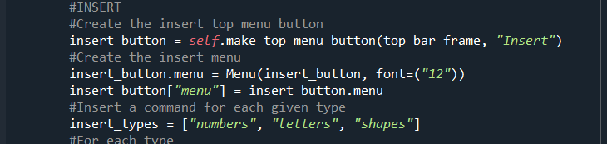

Upon the next launch of the application, your new shape type and shape will appear.

Changing the information/about pages

To change the contents of the information page:

1. Navigate to the html_info folder in the src folder.
2. Open the html_information.html file in an editor.
3. Make your changes.

Any changes made will appear in the application upon the next time the page is opened (provided you save your changes).